MODERN PHYSICS

DUAL NATURE OF MATTER AND RADIATION
# dual nature k teen part h PEE, D B aur radiation force blah blah blah...
DE BROGLIE WAVES AND RADIATION PRESSURE
Photoelectric Effect
# E(eV) = 12400 / λ(Å) or 1240 / λ(nm) {1240//1242} :)
Introduction to Photoelectric Effect, Photoelectrons, and Photo Current
- Definition of Photoelectric Effect:
When electromagnetic radiation (light) of a frequency greater than or equal to a minimum characteristic value falls on a metallic surface, electrons are liberated from the metal surface. This phenomenon is known as the photoelectric effect.
- Photoelectrons:
The electrons emitted from the metal surface during the photoelectric effect are called photoelectrons.
- Photo Current:
The rate of flow of emitted photoelectrons across the circuit constitutes an electric current termed the photo current.

Threshold Frequency (ν₀), Work Function (ϕ), and Cut-off Wavelength (λ₀)
Threshold Frequency (ν₀):
- The minimum frequency of incident light required to initiate photoelectron emission from a given metal surface.
- If the incident frequency ν < ν₀, no photoelectric emission occurs regardless of light intensity or exposure duration.
- Threshold frequency is strictly metal-dependent (varies from metal to metal).
Work Function (ϕ):
- The minimum energy required to remove a bound electron from a metal surface.
- Formula: ϕ = h * ν₀ = (h * c) / λ₀. # (1 eV = 1.6×10⁻¹⁹ J)
- SI Unit: Joule (J), commonly expressed in electron-volts (eV).
- Work function depends exclusively on the nature of the metal surface.
Cut-off Wavelength / Threshold Wavelength (λ₀):
- The maximum wavelength of incident light up to which the photoelectric effect will occur.
- If incident wavelength λ > λ₀, photoelectric emission ceases completely.
Formula: λ₀ = c / ν₀ = (h * c) / ϕ.
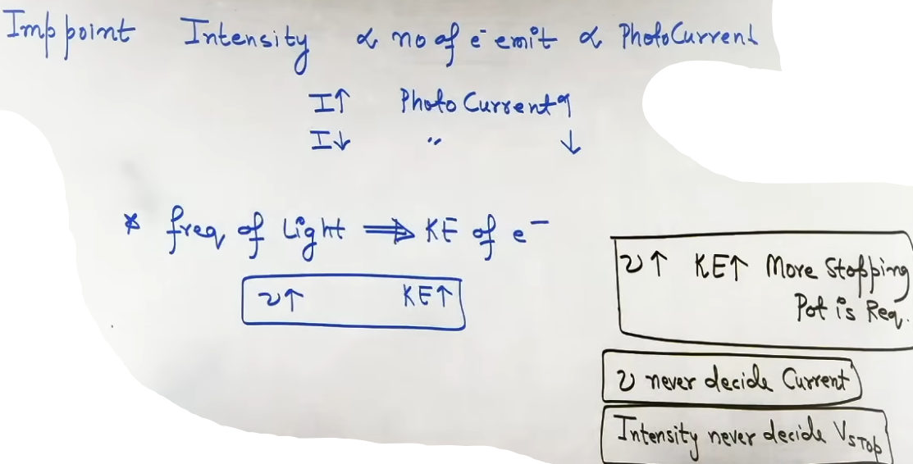
Experimental Observations and Graphs
1. Effect of Light Intensity on Photo Current:
- When frequency ν > ν₀ is kept constant, the photo current is directly proportional to the intensity of incident light.
- Increasing light intensity increases the number of photoelectrons emitted per second, thereby increasing the photo current linearly.

2. Instantaneous Emission Process:
- The emission of photoelectrons is an instantaneous process.
- The time interval between the incidence of radiation and the emission of photoelectrons is less than 10⁻⁹ seconds.

3. Effect of Light Frequency on Photo Current:
- Photo current does not depend on incident light frequency once the frequency exceeds threshold frequency ν₀.
- If ν < ν₀, photo current is strictly zero.
- Once ν ≥ ν₀, photo current rises instantaneously to a constant saturation value dictated by light intensity.

4. Effect of Applied Collector Potential (Voltage) on Photo Current:
- At zero applied voltage (V = 0), a non-zero photo current exists because emitted electrons possess initial kinetic energy and scatter toward the collector.
- As positive potential (accelerating voltage) on the collector increases, scattered photoelectrons are pulled in, causing a slight initial increase in photo current.
- Beyond a certain positive potential, photo current becomes constant and stops increasing despite further increases in positive voltage.

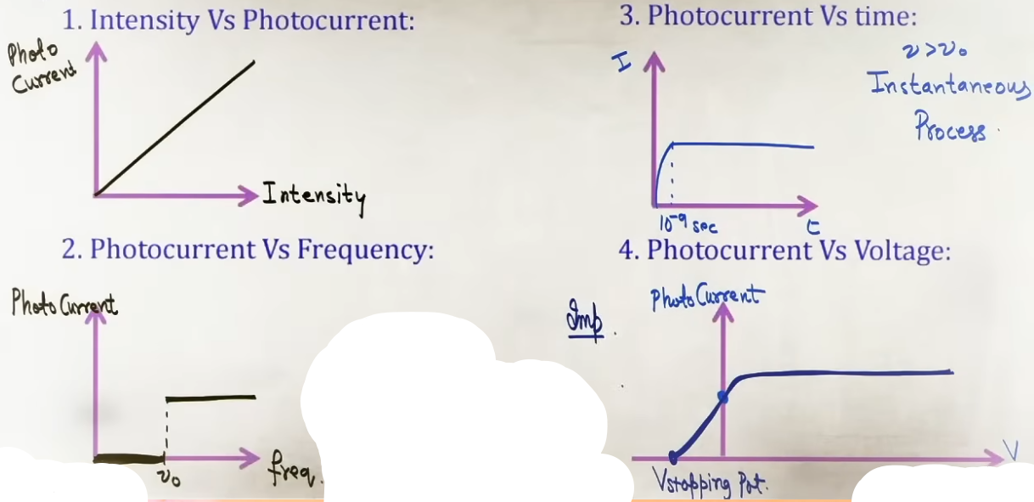
Saturation Current and Stopping Potential (Cut-off Voltage)
Saturation Current:
- The maximum constant photo current achieved when all photoelectrons emitted per second from the emitter plate reach the collector plate.
- Saturation current is decided exclusively by light intensity (higher intensity gives higher saturation current).

Stopping Potential (V_s / Cut-off Voltage):
- When a negative (retarding) potential is applied to the collector plate relative to the emitter, emitted photoelectrons experience electrostatic repulsion.
- Stopping Potential (V_s) is the minimum negative potential applied to the collector plate at which the photo current is reduced to exactly zero.
- At stopping potential V_s, even the most energetic photoelectron possessing maximum kinetic energy (K_max) is stopped right before reaching the collector.
“Fundamental Relation: K_max = e * V_s.”
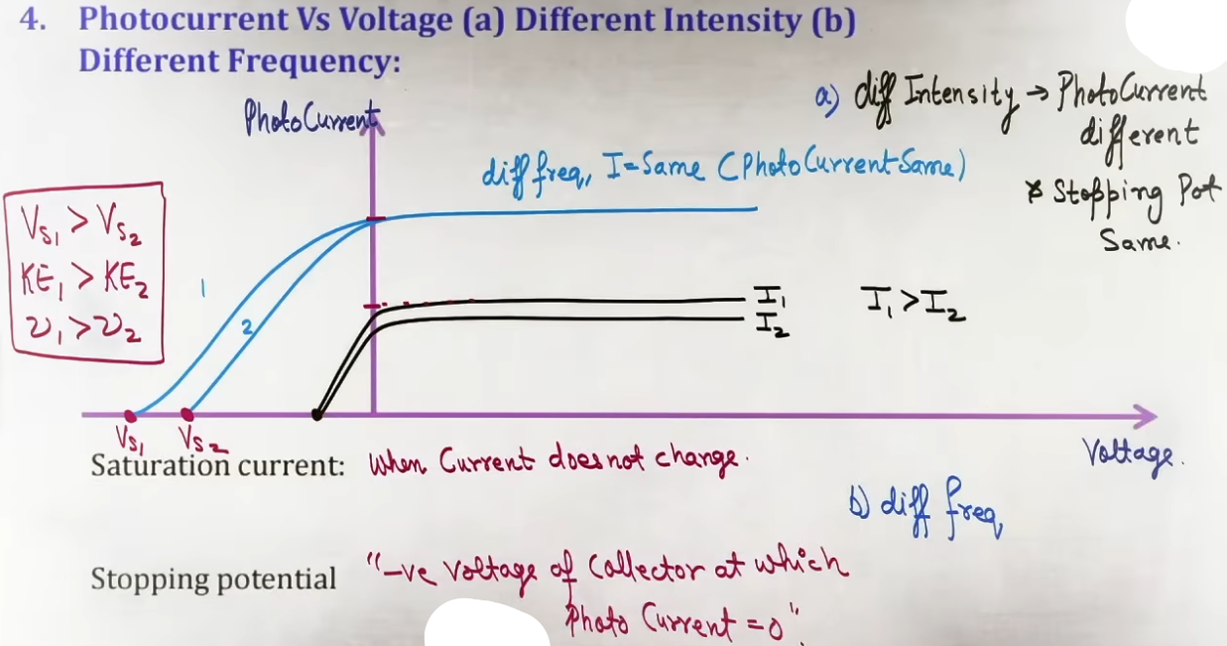
- Graph Analysis - Varying Intensity at Fixed Frequency:
- Saturation currents differ (higher intensity I₁ > I₂ produces higher saturation current).
- Stopping potential V_s remains EXACTLY THE SAME for all intensities because frequency is constant.

- Graph Analysis - Varying Frequency at Fixed Intensity:
- Saturation current remains EXACTLY THE SAME because intensity is constant.
- Stopping potentials differ (|V_s1| > |V_s2| for ν₁ > ν₂), meaning higher frequency requires a more negative stopping potential.

Failure of Classical Wave Theory of Light
Classical wave theory failed to explain the photoelectric effect due to three irreconcilable contradictions with experimental observations:
1. The Time Lag Problem:
Wave theory assumes light energy is spread continuously across a wavefront.
Calculations implied an electron on a metal surface would take a considerable time gathering wave energy continuously until accumulating enough energy equal to the work function.
Contradiction: Experimentally, emission is instantaneous (time lag < 10⁻⁹ s).
2. The Intensity vs Kinetic Energy Problem:
Wave theory asserts light intensity represents wave amplitude and energy per unit area per unit time.
Increasing intensity should deliver more wave energy per electron, imparting higher kinetic energy and increasing stopping potential.
Contradiction: Experimentally, kinetic energy K_max and stopping potential V_s are independent of intensity and depend solely on frequency.
3. The Threshold Frequency Problem:
Wave theory predicts light of any frequency, if made sufficiently intense or shone for long enough, should accumulate enough energy to eject electrons.
Contradiction: Experimentally, no photoelectrons are emitted if ν < ν₀, regardless of intensity or exposure time.

INTUITION AND CONCEPTUAL UNDERSTANDING

- Mental Model - Quanta / Photons vs Continuous Waves:
Classical wave theory treats light energy like a continuous hose stream spraying water over an area. An electron would have to wait for enough water to fill its bucket before jumping out.
Einstein's quantum model treats light like hail or bullets (photons). Energy arrives in localized packets E = h * ν. An electron gets hit by a single bullet instantaneously.
- One-to-One Collision Principle:
Photoelectric emission is a 1-to-1 interaction between one incident photon and one bound electron inside the metal.
If the single incoming photon possesses energy h * ν ≥ ϕ, the electron absorbs it instantaneously and escapes.
If h * ν < ϕ, the photon cannot eject the electron, no matter how many other sub-threshold photons strike the surface simultaneously.

- Real-Life Analogy for Intensity vs Frequency:
- Intensity = Number of photons delivered per second (brightness).
- Frequency = Energy contained inside each individual photon.
- Analogy: Dropping 100 ping-pong balls (high intensity, low frequency) onto a glass pane will not break it. Dropping a single steel cannonball (low intensity, high frequency) shatters the glass instantly.

FORMULA SHEET
- Work Function:
ϕ = h * ν₀ = (h * c) / λ₀
Units: Joule (J) or Electron-Volt (eV)
Condition: Surface property of a specific metal.

- Threshold Frequency and Cut-off Wavelength:
ν₀ = ϕ / h
λ₀ = (h * c) / ϕ = c / ν₀

- Einstein's Photoelectric Equation:
E_incident = Work Function + K_max
h*ν = ϕ + K_max
hν = hν₀ + (1/2)m(v_max)²
Condition: K_max represents the MAXIMUM possible kinetic energy of emitted photoelectrons.

- Stopping Potential Equations:
K_max = e*V_s
eV_s = h*ν - ϕ
V_s = (h/e)*ν - (ϕ/e)

Parameter Dependence Table:
Parameter Changed | Impact on Photo Current / Saturation Current | Impact on K_max | Impact on Stopping Potential V_s
Increase Intensity (Fixed ν) | Increases Linearly | No Change | No Change
Decrease Intensity (Fixed ν) | Decreases Linearly | No Change | No Change
Increase Frequency (Fixed Intensity) | No Change | Increases Linearly | Becomes More Negative
Decrease Frequency (ν > ν₀) | No Change | Decreases Linearly | Becomes Less Negative
Frequency ν < ν₀ | Drops to Zero | Zero (No Emission) | Zero

PROBLEM-SOLVING FRAMEWORK

On mixed Light Frequencies Incident on Metal, light equation contains multiple frequencies (e.g. E = E₁ cos ω₁t + E₂ cos ω₂t)
1. Identify highest frequency ν_max = ω_max / 2π.
2. Stopping potential is determined EXCLUSIVELY by ν_max. Highest frequency component determines K_max and V_s.

# E(eV) = 12400 / λ(Å) or 1240 / λ(nm) # (1 eV = 1.6×10⁻¹⁹ J)
JEE ADVANCED INSIGHTS

1. Universal Slope of V_s vs ν Graphs:
The slope of the Stopping Potential (V_s) versus Frequency (ν) graph is m = h / e. Since Planck's constant h and elementary charge e are universal constants, the slope of V_s vs ν is identical for every photosensitive metal.

2. Shifted Origin Traps in Graphs:
Exams frequently shift the origin of the V_s vs ν graph (e.g. starting the X-axis at ν = 4 × 10¹⁴ Hz instead of 0). Do not blindly read the visual axis intersection as ν₀. Always check the numerical coordinate values at the intercept.

3. Maximum vs Range of Kinetic Energies:
Einstein's equation h * ν = ϕ + K_max yields the MAXIMUM kinetic energy of photoelectrons (emitted from the top surface layer without collisions).
Internal electrons undergo multiple scattering collisions inside the bulk metal before escaping, losing varying amounts of energy. Thus, emitted photoelectrons possess a continuous range of kinetic energies: 0 ≤ K ≤ K_max.

HIGH-YIELD REVISION SHEET
MUST REMEMBER:

Key Formulas:
- Work Function: ϕ = hν₀ = (hc)/λ₀
- Einstein's Equation: hν = ϕ + K_max = hν₀ + e(V_s)
- Stopping Potential: V_s = (h/e)*ν - (ϕ/e)
- Maximum Kinetic Energy: K_max = e*V_s = (1/2)m(v_max)²

Key Observations:
1. Intensity ∝ Number of photoelectrons emitted per second ∝ Saturation photo current.
2. Frequency ∝ Photon Energy ∝ Maximum Kinetic Energy (K_max) ∝ Stopping Potential Magnitude (|V_s|).
3. Emission is instantaneous (< 10⁻⁹ s time lag).
4. Emitted photoelectrons have kinetic energies ranging continuously from 0 to K_max.
5. Slope of V_s vs ν graph is universally constant = h / e.

--------------------------------------------------------------------------------

EINSTEIN'S QUANTUM/PHOTON THEORY AND PHOTOELECTRIC EQUATION
Photon Hypothesis:
- Light/radiation does not transfer energy continuously like classical waves, but propagates in localized, discrete energy packets called quanta or photons.
- Energy of a single photon: E = h * ν = hc/λ
where h is Planck's constant (6.63 × 10⁻³⁴ J·s), ν is frequency, c is speed of light (3 × 10⁸ m/s), and λ is wavelength.
- Total energy for N photons: E_total = N*h*ν = N*(hc)/λ.

1-to-1 Photon-Electron Interaction Principle:
- The photoelectric interaction is a discrete, "instantaneous" 1-to-1 collision between one incident photon and one bound electron inside the metal.
- A photon gives up its entire energy to a single electron upon collision. It cannot divide its energy among multiple electrons, nor can an electron accumulate energy from multiple sub-threshold photons.

- The intensity of light is directly proportional to no. of photons, hence if intensity increases the no of photon incident increases which leads to more emission of electrons (riso of photocurrent)

Conservation Laws in Photoelectric Emission:
- In every photon-electron collision, total energy and total linear momentum are conserved.
Einstein's Photoelectric Equation:
- By conservation of energy:
E_incident = Work Function (ϕ) + Maximum Kinetic Energy (K_max)
h*ν = h*ν₀ + (1/2)*m*(v_max)²
(h*c)/λ = (h*c)/λ₀ + (1/2)*m*(v_max)²

Relation to Stopping Potential (V_s):
- The maximum kinetic energy K_max equals the electrostatic work done by retarding potential V_s to stop the fastest electron:
K_max = e * V_s
(h*c)/λ = (h*c)/λ₀ + e*V_s

- If the frequency of light increases the kinetic energy of photo electron increases, hence the stopping potential. # explanation on next part

- No. of photons incident is not equal to no of electron emitted.

- For a given incident frequency, the kinetic energy of emitted electron is not same, only few electrons have maximum kinetic energy. # exp. on next part

PHOTOELECTRIC EFFICIENCY (QUANTUM YIELD) AND PHOTON EMISSION RATE / POWER FORMULA
Photoelectric Efficiency (Quantum Yield):
- Defined as the ratio of the number of emitted photoelectrons per second to the number of incident photons absorbed per second:
- Photoelectric Efficiency = (Number of photoelectrons emitted per second / Number of photons absorbed per second) * 100%
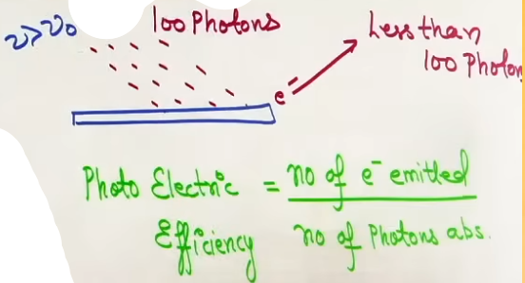
In real metal surfaces, photoelectric efficiency is very low (typically less than 1%).
Reason: Most absorbed photons interact with bulk electrons beneath the surface. These electrons lose kinetic energy through multiple collisions with the metal lattice before escaping, leaving only a small fraction to emerge with maximum kinetic energy K_max.
Range of kinetic energies of emitted photoelectrons: 0 ≤ K ≤ K_max.

Photon Emission Rate (n_p) and Source Power Formula:
- Let a monochromatic light source of power P emit light of wavelength λ and frequency ν.
Energy of each photon: E_p = h * ν = (h * c) / λ
Energy of N photon: E = Nhν = (N)(hc)/λ
Power (P) = Energy/time = (N)h*ν/t = (N/t)(h*ν) = n_p*E_p
where n_p = N/t is the number of photons emitted per second.
Photon Emission Rate Formula:
n_p = P / E_p = (P*λ)/(h*c)
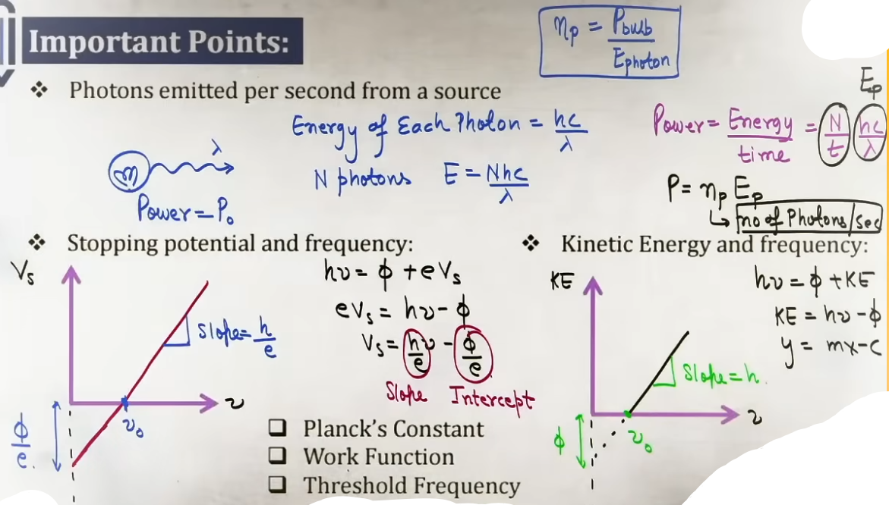
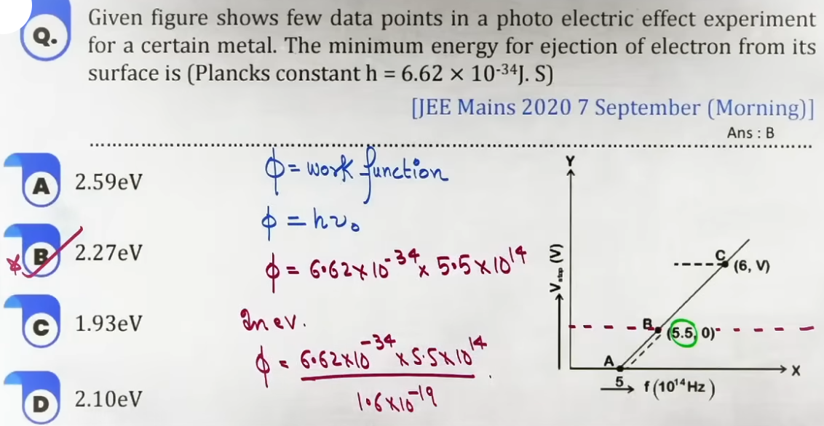
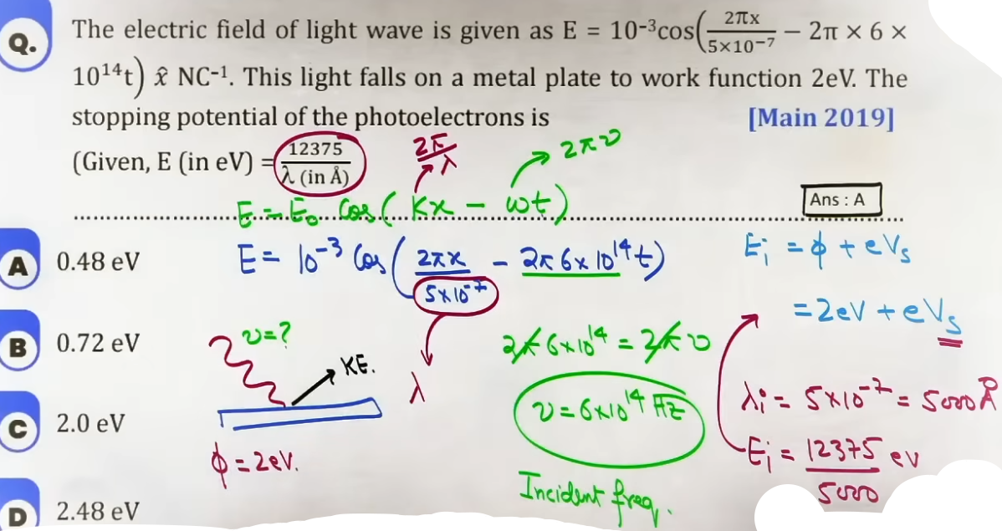
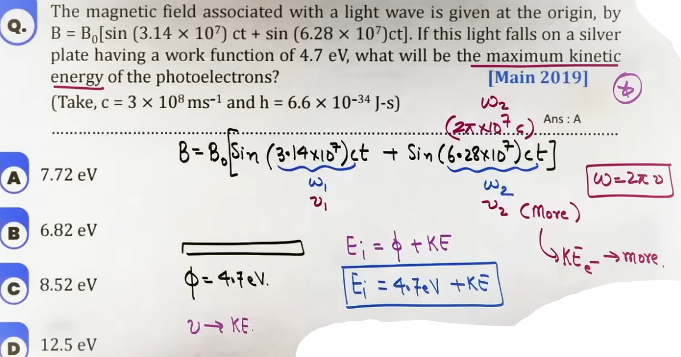

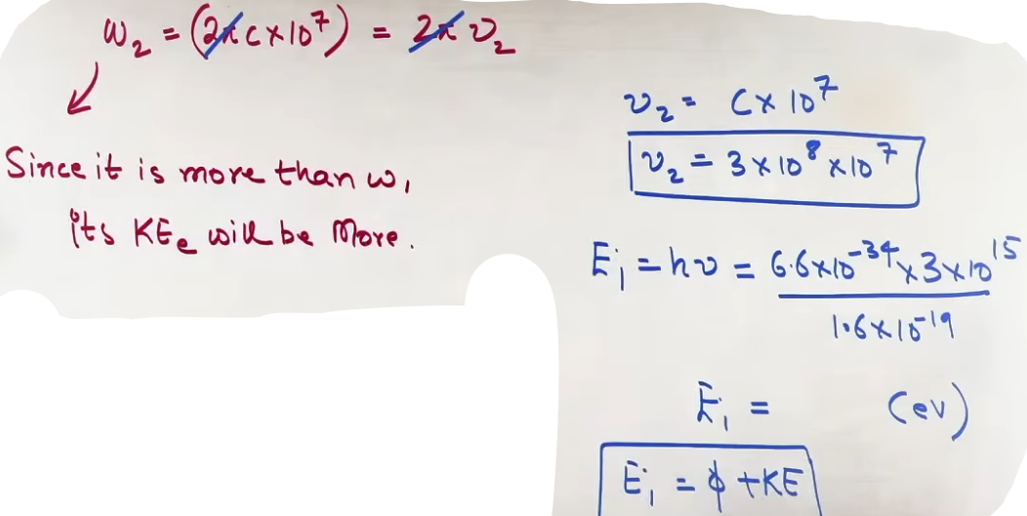
DE BROGLIE MATTER WAVE HYPOTHESIS AND WAVELENGTH CALCULATIONS
De Broglie Hypothesis:
- Nature exhibits fundamental symmetry. If light waves exhibit particle-like properties (photons), moving material particles must exhibit wave-like properties (matter waves).
Associated De Broglie Wavelength (λ):
λ = h/p = h/(mv)
where p is particle momentum, m is mass, and v is velocity.

Photon Momentum:
- For a photon of energy E = hc/λ, rest mass is zero, but momentum is:
p = E/c = h/λ.
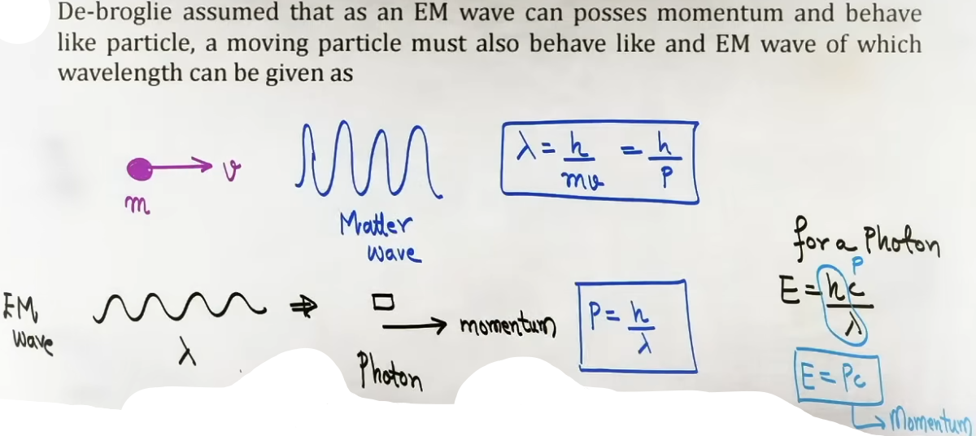
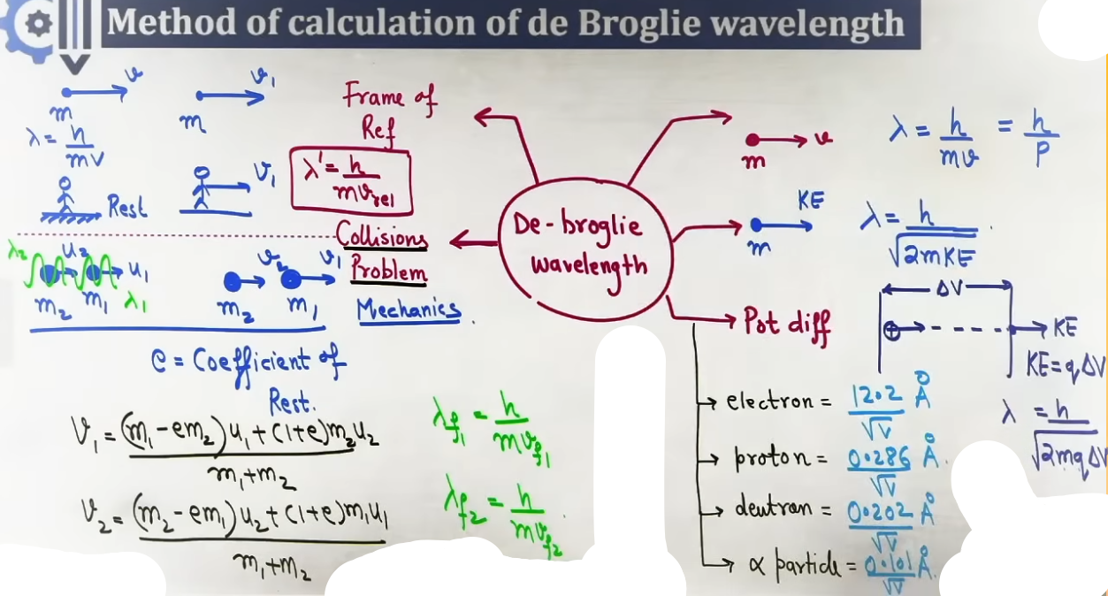
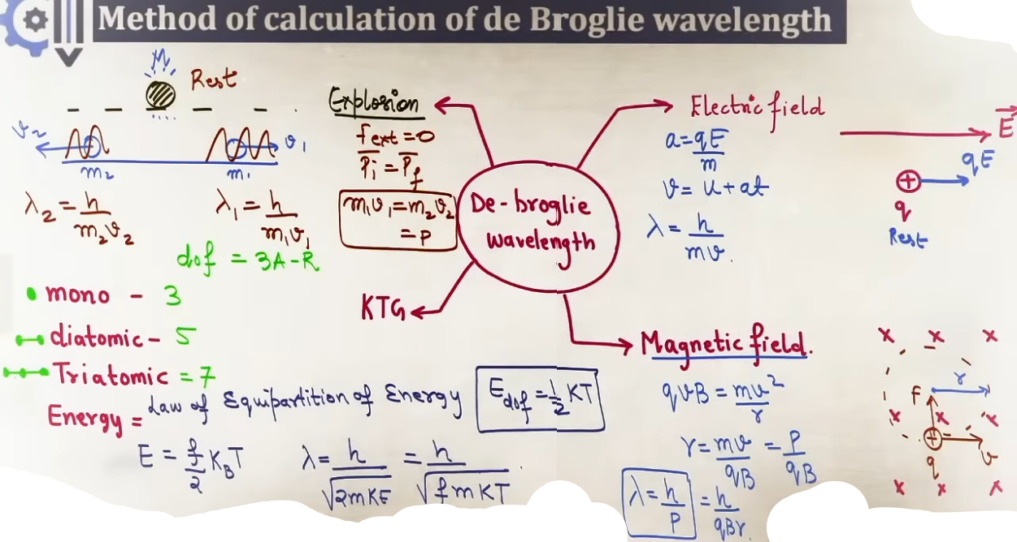
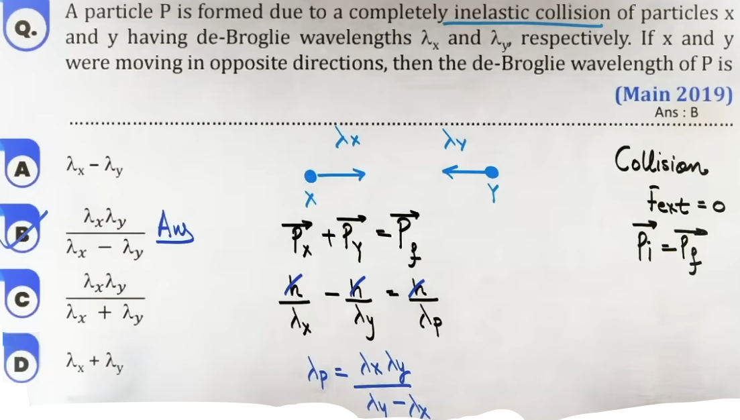
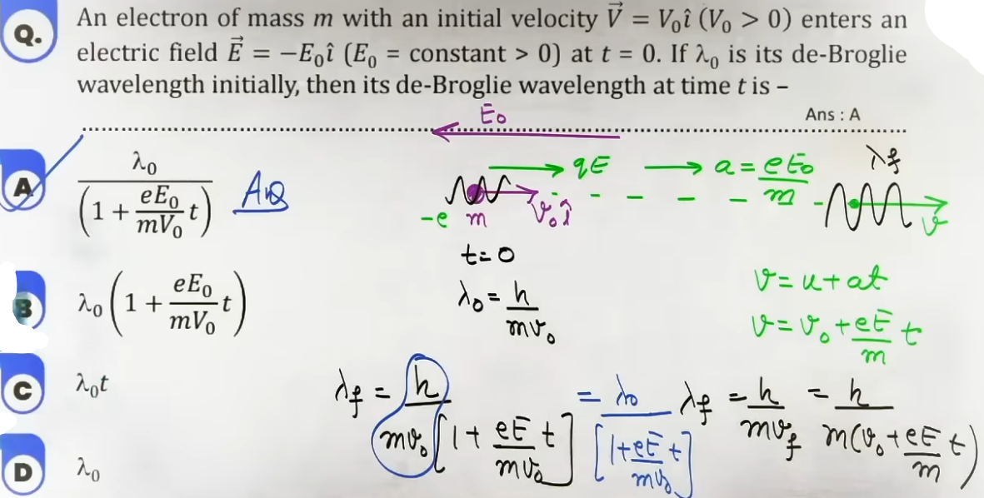
RADIATION FORCE AND RADIATION PRESSURE
Physical Mechanism:
Photons carry linear momentum p = E/c. When light strikes a surface, momentum transfer occurs, generating radiation force F_rad = Δp/Δt and radiation pressure P_rad = F_rad/Area.
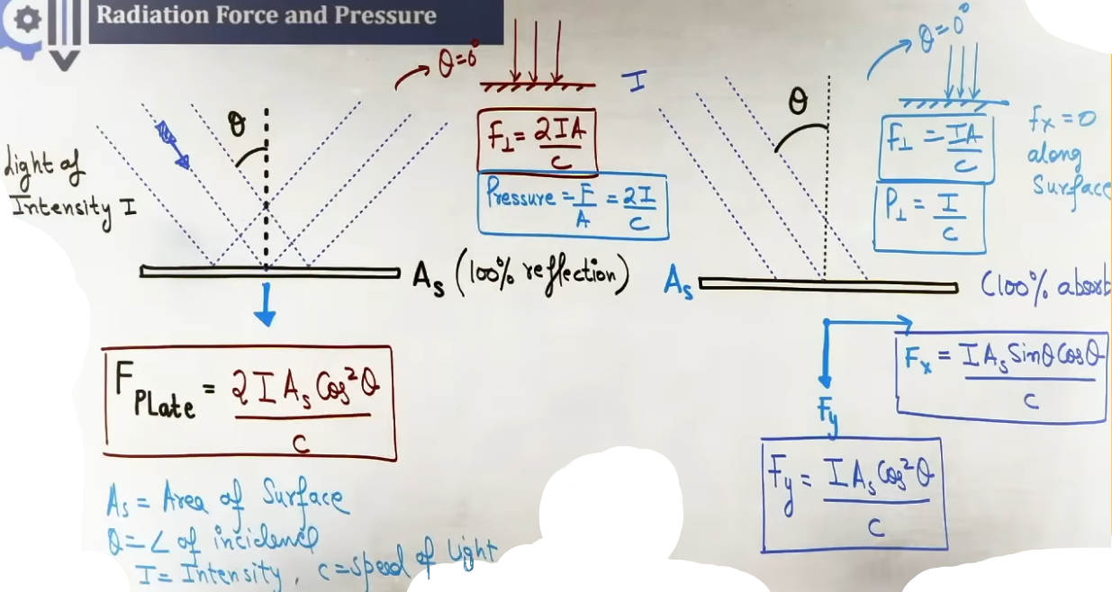
Case 1: Inclined Incidence (Angle θ with Surface Normal, Intensity I, Surface Area A)
- 100% Absorbing Surface:
Perpendicular Force: F_perp = (IAcos²θ)/c
Parallel/Tangential Force: F_parallel = (IAsinθcosθ)/ c
Radiation Pressure: P_rad = F_perp / A = (Icos²θ)/c
- 100% Reflecting Surface:
Perpendicular Force: F_perp = (2IAcos²θ)/c
Parallel/Tangential Force: F_parallel = 0
Radiation Pressure: P_rad = F_perp/A = (2Icos²θ)/c

Case 2: Radiation Force on 3D/Curved Objects (Beam of Intensity I along symmetry axis)
- Cone or Cylinder (Base Radius R, Base Area A_proj = πR²):
100% Absorbing: F = (IπR²)/c
100% Reflecting: F = (2IπR²)/ c
- Sphere of Radius R (Cross-sectional Area A_proj = πR²):
CRUCIAL DERIVATION RESULT:
100% Absorbing Sphere: F = (IπR²)/c
100% Reflecting Sphere: F = (IπR²)/c
(SPECIAL NOTE: Due to integration of force components over the spherical curved surface, the factor of 2 cancels out for a reflecting sphere. Both 100% absorbing and 100% reflecting spheres experience the EXACT SAME FORCE F = IπR²/c).
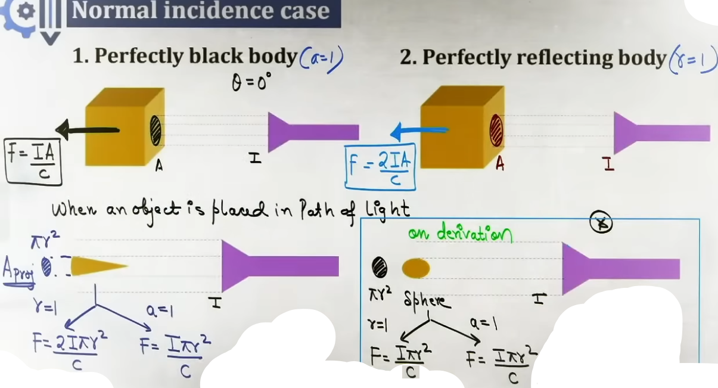
# r = 1 matlab perfectly reflecting, a = 1 matlab perfectly absorbing.
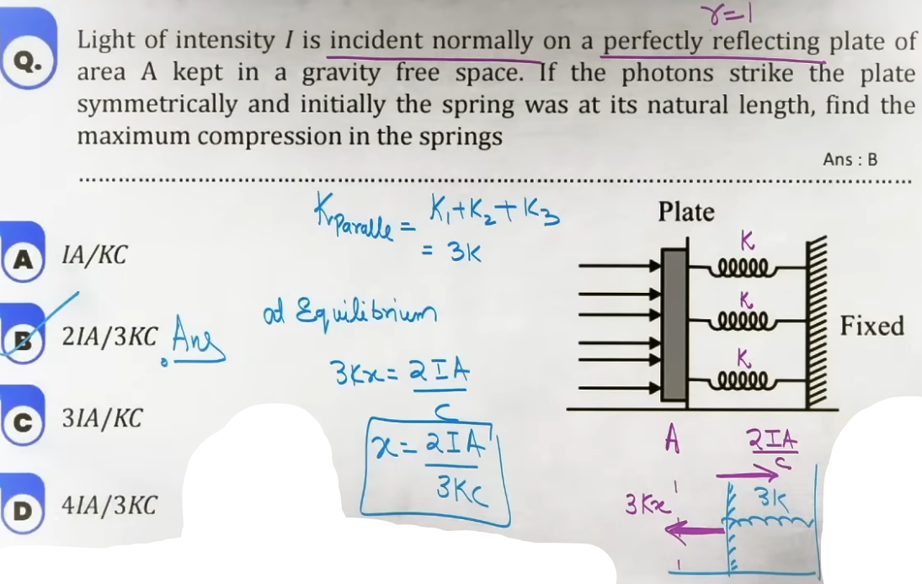
# sphere exception
FORMULA SHEET

- Einstein's Photoelectric Equation:
h * ν = ϕ + K_max = h * ν₀ + e * V_s
K_max = e * V_s = (1/2) * m * (v_max)²

- Stopping Potential:
V_s = (h/e)*ν - (ϕ / e) = (hc/e)*(1/λ) - (ϕ / e)

- Photon Emission Rate (Photons/sec emitted by source of Power P):
n_p = N_p / t = P / E_p = (P * λ) / (h * c)

- De Broglie Wavelength Formulas:
General: λ = h/p = h/(mv)
Kinetic Energy Form: λ = h/√(2mK)
Voltage Accelerated Charge Form: λ = h/√(2mqV)

- Accelerated Particle Shortcuts (V in Volts, λ in Ångströms):
Electron : λ_e = 12.27 / √V Å
Proton : λ_p = 0.286 / √V Å
Deuteron : λ_d = 0.202 / √V Å
Alpha Particle: λ_α = 0.101 / √V Å

- De Broglie Application Formulas:
Thermal Gas: λ_thermal = h / √(3 * m * k_B * T)
Magnetic Field B (Radius R): λ = h/(qBR)
Perpendicular Fused Collision: λ_net = (λ₁ * λ₂) / √(λ₁² + λ₂²)
Explosion at Rest: λ₁ = λ₂

- Radiation Force & Pressure Formulas (Normal Incidence, Beam Power P = I*A):
100% Absorbing: F = (I*A)/c; P_rad = I / c
100% Reflecting (Flat Surface): F = (2IA) / c; P_rad = 2I/c
100% Reflecting Sphere (Radius R): F = (IπR²)/c

CONCEPT CONNECTIONS

- Connection to Kinetic Theory of Gases (KTG):
Translational kinetic energy K = (3/2) k_B * T bridges thermal thermodynamics to quantum matter waves λ = h/√(3m k_B T).

Comparison Table: Radiation Force on Geometries :
Geometry | 100% Absorbing Surface | 100% Reflecting Surface
Flat Plate (Normal θ=0) | (IA)/c | (2IA)/c
Flat Plate (Angle θ) | (IAcos²θ)/c | (2IAcos²θ)/c
Cylinder / Cone | (IπR²)/c | (2IπR²)/c
Sphere | (IπR²)/c | (IπR²)/c (Special Exception!)

JEE ADVANCED INSIGHTS

1. Reflecting Sphere Force Equivalence:
A flat 100% reflecting plate experiences force F = 2IA/c. But a 100% reflecting SPHERE experiences force F = IπR²/c (same as an absorbing sphere!). Do not insert the factor of 2 for a sphere in numericals.

2. Identical Wavelength Fragile Decays:
When a stationary particle breaks into two fragments of masses m₁ and m₂, both fragments MUST have identical De Broglie wavelengths (λ₁ = λ₂), regardless of mass ratio, because linear momentum is conserved equally in opposite directions.

HIGH-YIELD REVISION SHEET
MUST REMEMBER:

Key Formulas:
- Einstein's Photoelectric Equation: h * ν = ϕ + K_max = ϕ + e * V_s
- Photon Emission Rate: n_p = P / E_p = (P * λ) / (h * c)
- De Broglie Wavelength: λ = h / p = h / (m * v) = h / √(2 * m * K)
- Accelerated Charges: λ = h / √(2 * m * q * V)
- Electron Shortcut: λ_e = 12.27 / √V Å
- Proton Shortcut: λ_p = 0.286 / √V Å
- Alpha Shortcut: λ_α = 0.101 / √V Å
- Thermal Gas Wavelength: λ = h / √(3 * m * k_B * T)
- Orthogonal Fusion Collision: λ_net = (λ₁ * λ₂) / √(λ₁² + λ₂²)
- Explosion at Rest: λ₁ = λ₂
- Radiation Force (Flat Absorbing): F = (I * A) / c
- Radiation Force (Flat Reflecting): F = (2 * I * A) / c
- Radiation Force (Sphere Reflecting or Absorbing): F = (I * π * R²) / c
--------------------------------------------------------------------------------

ATOMS

Overview of Atomic Models
Thomson's Model (Plum Pudding / Watermelon Model):
- An atom is envisioned as a uniform sphere of positive charge of radius approximately 10⁻¹⁰ m in which negative electrons are embedded throughout like seeds in a watermelon.
Failure: Failed to explain large-angle scattering of alpha particles and discrete atomic spectral lines.

Rutherford's Alpha Particle Scattering Experiment:
- Experimental Setup: High-energy alpha particles (He²⁺, mass = 4 amu, charge = +2e) emitted from a radioactive bismuth/polonium source are collimated into a narrow beam and directed toward a thin gold foil (thickness ≈ 2.1 × 10⁻⁷ m).
Why Gold Foil was Chosen:
1. Gold is extremely malleable and can be hammered into an ultrathin foil (ensures a single scattering event per alpha particle).
2. Gold has a high atomic number (Z = 79), providing a massive, heavy nucleus that remains stationary during interaction, so all observable momentum change occurs in the lighter alpha particle.

Observations, Graphs, and Drawbacks of Rutherford's Model
Experimental Observations:
1. Overwhelming majority (> 99.9%) of alpha particles pass straight through the gold foil without any measurable deflection.
2. A small fraction (approx. 1 in 8000 or 0.14%) is deflected by small angles (θ > 1°).
3. An extremely tiny fraction (less than 1 in 8000) is deflected through large angles (θ > 90°), with very few rebounding almost straight back (θ ≈ 180°).
Conclusions / Interpretations:
1. Atom is mostly empty space.
2. The entire positive charge and almost the entire mass of the atom are concentrated in a tiny, dense core called the nucleus.
3. The nucleus occupies a minute fraction of the total atomic volume (nucleus radius ~ 10⁻¹⁵ m vs atom radius ~ 10⁻¹⁰ m).

Drawbacks of Rutherford's Model:
1. Inability to Explain Atomic Orbital Stability (Collapse of Atom): According to classical electromagnetic theory, an accelerating charge (electron revolving in a circular orbit) must continuously radiate energy in the form of electromagnetic waves. Losing energy causes its orbital radius to decrease continuously, producing a spiral trajectory that ends with the electron collapsing into the nucleus within 10⁻¹⁰ seconds.
2. Inability to Explain Discrete Line Spectra: Continuous energy loss predicts a continuous spectrum containing all frequencies. Experimentally, atoms emit discrete, sharp spectral lines.
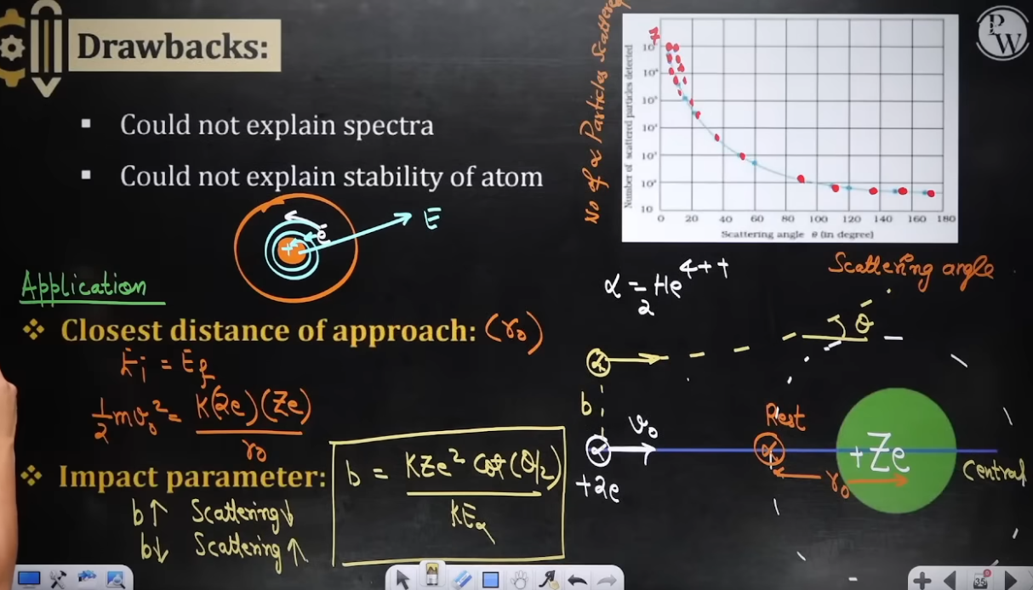
Distance of Closest Approach (r₀) and Impact Parameter (b)
Distance of Closest Approach (r₀):
- Definition: The minimum distance from the center of the target nucleus to which an alpha particle traveling directly along the central axis (head-on collision) can approach before coming to instantaneous rest and reversing its motion.
# Derivation via Conservation of Mechanical Energy:
r₀ = (2 k Z e²) / K_α = (4 k Z e²) / (m_α v₀²)
where k = 1 / (4π ε₀) ≈ 9 × 10⁹ N m²/C², Z is target atomic number, e = 1.6 × 10⁻¹⁹ C, m_α is alpha particle mass.

Impact Parameter (b): # not so imp :P
- Definition: The perpendicular distance between the initial velocity vector of the alpha particle (when far from the nucleus) and the parallel central axis passing through the nucleus.
Mathematical Formula:
b = [Ze²cot(θ/2)]/[4πε₀K_α] = [kZe²cot(θ/2)]/[(1/2)m_αv₀²]

- Key Relationships:
1. Large Impact Parameter b: Alpha particle passes far from the nucleus, experiencing weak Coulomb repulsion -> Small scattering angle θ.
2. Small Impact Parameter b: Alpha particle passes close to the nucleus, experiencing strong Coulomb repulsion -> Large scattering angle θ.
3. Zero Impact Parameter (b = 0): Head-on collision along the central axis -> Maximum scattering angle θ = 180° (alpha particle bounces straight back).

Bohr's Postulates for Hydrogen and Hydrogen-like Atoms
Applicability: Valid strictly for single-electron species (such as H, He⁺, Li²⁺, Be³⁺) with atomic number Z and nuclear charge +Ze.
- Postulate 1 (Stationary Orbits and Centripetal Force Balance):
An electron revolves around the positive nucleus in specific non-radiating circular orbits. The electrostatic Coulomb attraction between the nucleus (+Ze) and the electron (-e) provides the necessary centripetal force:
F_centripetal = F_electrostatic
(m * v²) / r = (1 / (4π ε₀)) * (Z * e²) / r² = (k * Z * e²) / r²
- Postulate 2 (Quantization of Orbital Angular Momentum):
An electron can revolve only in those non-classical stationary orbits where its orbital angular momentum L is an integral multiple of h / (2π):
L = mvr = (n)*(h/2π) where n = 1, 2, 3... (principal quantum number).
- Postulate 3 (Transition and Energy Quantum Condition):
An electron in a stationary orbit does not radiate energy. Electromagnetic radiation is emitted or absorbed only when an electron jumps from one permitted orbit to another:
ΔE = E₂ - E₁ = h * ν = (h * c) / λ
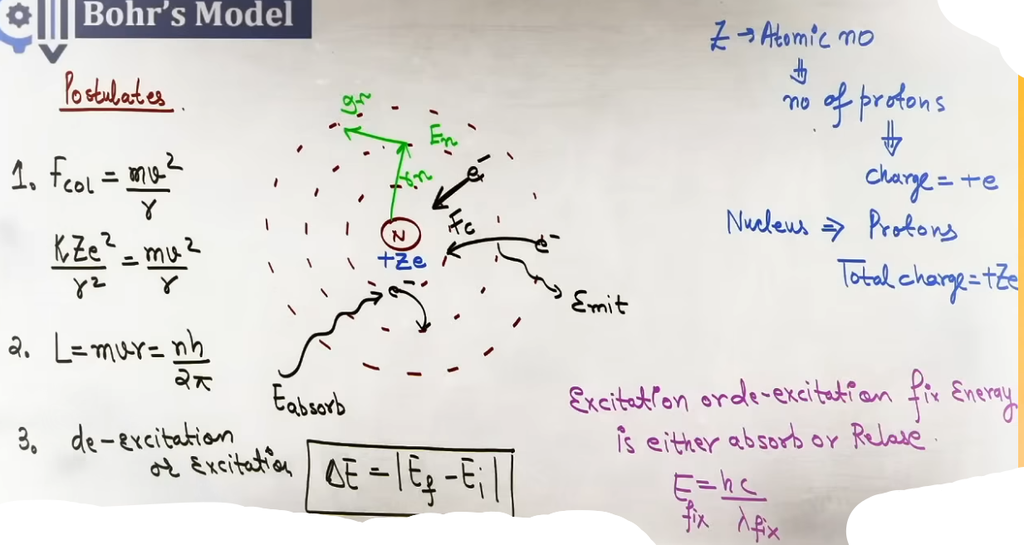
Derived Formulas for n-th Orbit Parameters
Solving Postulates 1 and 2 simultaneously yields all physical parameters for an electron in the n-th orbit:
- 1. Radius of n-th Orbit (r_n):
From L = m v r = n h / (2π) => v = n h / (2π m r).
Substituting v into (m v²) / r = (k Z e²) / r²:
r_n = [ n² h² ε₀ ] / [ π m Z e² ] = r₀*(n²/Z) = 0.529*(n²/Z) Å
where r₀ = a₀ = 0.529 Å = 0.0529 nm is the Bohr radius (ground state radius of hydrogen, n=1, Z=1).
Proportionality: r_n ∝ n² / Z.

- 2. Velocity of Electron in n-th Orbit (v_n):
v_n = [ Z e² ] / [ 2 ε₀ n h ] = v₀*(Z/n) = 2.18 × 10⁶*(Z/n) m/s
where v₀ = 2.18 × 10⁶ m/s is the orbital velocity in the ground state of hydrogen (v₀ ≈ c / 137).
Proportionality: v_n ∝ Z / n.

- 3. Energies of Electron in n-th Orbit (E_n, K_n, U_n):
Kinetic Energy (K_n): K_n = (1/2)m(v_n²) = (kZe²)/(2r_n) = +13.6*(Z²/n²) eV.
Potential Energy (U_n): U_n = - (k Z e²) / r_n = -27.2*(Z²/n²) eV.
Total Energy (E_n = K_n + U_n):
E_n = -(kZe²)/(2r_n) = -[mZ² e⁴ k² 2π²] / [ n²h² ] = -13.6*(Z²/n²) eV.
Fundamental Energy Inter-relationships:
K_n = - E_n
U_n = 2 * E_n
E_n = U_n / 2 = - K_n
Proportionality: E_n ∝ Z² / n², K_n ∝ Z² / n², U_n ∝ Z² / n².

- 4. Time Period of Revolution (T_n):
T_n = (2 π r_n) / v_n ∝ (n² / Z) / (Z / n) = n³ / Z².
Formula: T_n = T₀ * (n³ / Z²) where T₀ ≈ 1.52 × 10⁻¹⁶ s.
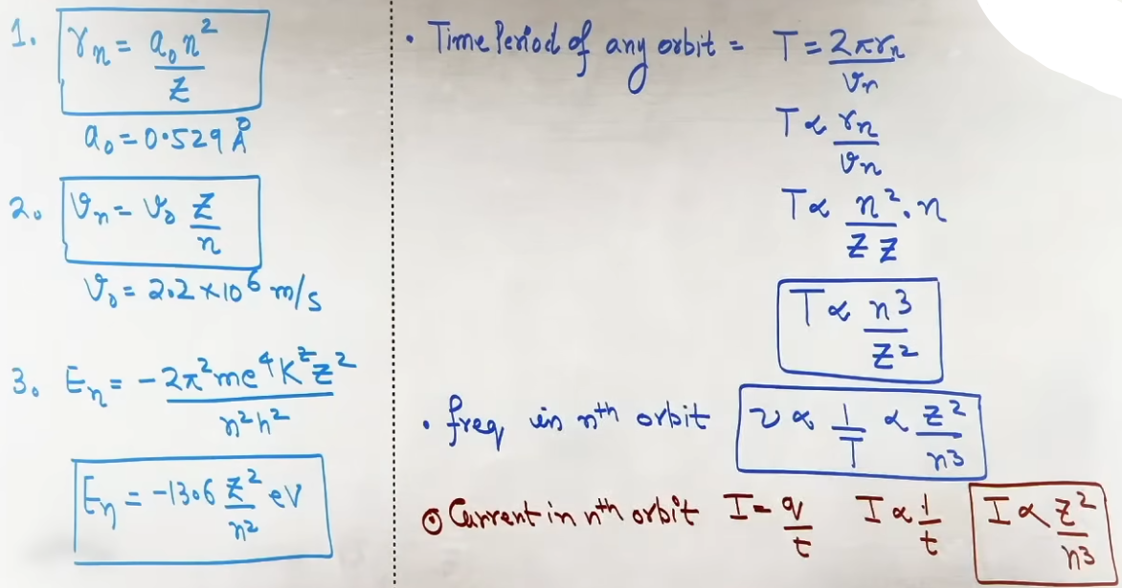
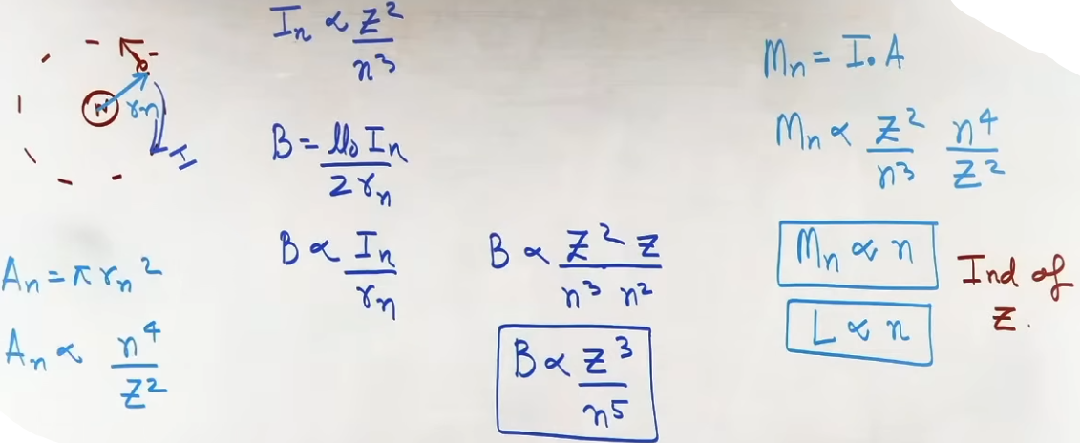
CRUCIAL OBSERVATION: Magnetic dipole moment M_n is directly proportional to principal quantum number n and is completely INDEPENDENT of atomic number Z!

INTUITION AND CONCEPTUAL UNDERSTANDING

- Impact Parameter and Deflection Geometry:
Think of a dart thrown toward a round target.
A dart aiming right at the bullseye (b = 0) hits dead center and bounces straight back (θ = 180°).
A dart aiming far to the side (large b) barely grazes the target's force field, deflecting by a tiny angle θ.

- Energy Relationships Intuition (The Negative Energy Well):
Total energy E_n is negative (-13.6 eV for H ground state) because the electron is trapped in a bound state inside the nucleus's attractive potential well.
To free the electron (move it to n = ∞ where E = 0), an external agency must supply energy equal to +13.6 eV (Ionization Energy).
Potential energy U_n is always twice as negative as total energy E_n (U_n = 2 E_n), while kinetic energy K_n is always positive and equal in magnitude to total energy (K_n = -E_n).

FORMULA SHEET
- Distance of Closest Approach (Head-on collision b = 0):
r₀ = (2 k Z e²) / K_α = (4 k Z e²) / (m_α v₀²)
Units: meters (m) or femtometers (1 fm = 10⁻¹⁵ m).

- Impact Parameter:
b = [ k Z e² cot(θ / 2) ] / K_α
Scattering Angle Relation: N(θ) ∝ 1 / sin⁴(θ / 2)

- Bohr Angular Momentum Quantization:
L = m * v * r = (n * h) / (2π)

- Bohr Orbital Parameters for n-th Orbit:
Radius : r_n = 0.529 * (n² / Z) Å
Velocity : v_n = 2.18 × 10⁶ * (Z / n) m/s
Total Energy : E_n = -13.6 * (Z² / n²) eV
Kinetic Energy : K_n = +13.6 * (Z² / n²) eV
Potential Energy: U_n = -27.2 * (Z² / n²) eV

- Scaling Proportionalities with Quantum Number n and Atomic Number Z:
Radius : r_n ∝ n² / Z
Velocity : v_n ∝ Z / n
Total / Kinetic / Potential Energy: E_n, K_n, U_n ∝ Z² / n²
Time Period : T_n ∝ n³ / Z²
Frequency of Revolution : f_n ∝ Z² / n³
Orbital Current : I_n ∝ Z² / n³
Magnetic Field at Center : B_n ∝ Z³ / n⁵
Magnetic Dipole Moment : M_n ∝ n (Independent of Z)

EXAMPLES AND APPLICATIONS

EXAMPLE 1: Ratio of Orbital Radius and Velocity
Problem: Calculate the ratio of the radius of the 3rd orbit of He⁺ (Z = 2) to the radius of the 2nd orbit of Li²⁺ (Z = 3).
Solution:
Radius formula: r_n ∝ n² / Z.
For He⁺ (n₁ = 3, Z₁ = 2): r₁ ∝ (3)² / 2 = 9 / 2 = 4.5.
For Li²⁺ (n₂ = 2, Z₂ = 3): r₂ ∝ (2)² / 3 = 4 / 3 ≈ 1.33.
Ratio r₁ / r₂ = (9 / 2) / (4 / 3) = (9 / 2) * (3 / 4) = 27 / 8 = 3.375.

EXAMPLE 2: Hypothetical Bohr Atom with Non-Standard Force (JEE Advanced Pattern)
Problem: Suppose an electron moves in a central potential field where potential energy is U(r) = C * r⁴. Assuming Bohr angular momentum quantization holds, find how orbit radius r depends on principal quantum number n.
Solution:
1. Force F(r) = -dU / dr = -d(C * r⁴) / dr = -4 C r³.
2. Centripetal force balance:
m * v² / r = 4 C r³ => m * v² = 4 C r⁴ => v² = (4 C r⁴) / m.
3. Bohr angular momentum quantization:
m * v * r = (n * h) / (2π) => v = (n * h) / (2 π m r).
4. Square velocity expression and equate:
v² = (n² h²) / (4 π² m² r²)
(4 C r⁴) / m = (n² h²) / (4 π² m² r²)
r⁶ = (n² h²) / (16 π² m C)
r ∝ n^(2/6) = n^(1/3).
Therefore, orbit radius r is directly proportional to n^(1/3).

JEE ADVANCED INSIGHTS

1. Magnetic Moment Independence from Z:
The orbital magnetic dipole moment M_n = I_n * A_n is directly proportional to principal quantum number n (M_n ∝ n) and is completely independent of atomic number Z. For any hydrogen-like ion in the ground state (n = 1), M₁ is identical (equal to one Bohr Magneton μ_B = e h / (4π m)).
2. Modified Force Law Procedure:
Whenever a problem introduces a hypothetical force (e.g., F ∝ rⁿ, U ∝ ln r, or U ∝ r^k), NEVER use memorized formulas like r ∝ n² or E ∝ 1/n². Always re-derive from first principles:
Step 1: Set m * v² / r = F(r).
Step 2: Set m * v * r = n * h / (2π).
Step 3: Eliminate v to solve for r(n), then compute E_total = K + U.

3. Distance of Closest Approach as Nuclear Size Upper Bound:
The distance of closest approach r₀ provides an upper boundary for the radius of the nucleus (R_nucleus < r₀). Alpha particles with kinetic energy up to ~ 5-10 MeV cannot penetrate the nucleus, so nuclear forces do not alter classical Coulomb scattering at these energies.

HIGH-YIELD REVISION SHEET

MUST REMEMBER:

Key Formulas:
- Distance of Closest Approach: r₀ = (2 k Z e²) / K_α = (4 k Z e²) / (m_α v₀²)
- Impact Parameter: b = [ k Z e² cot(θ / 2) ] / K_α
- Angular Momentum Quantization: m * v * r = (n * h) / (2π)
- Bohr Radius: r_n = 0.529 * (n² / Z) Å
- Orbital Velocity: v_n = 2.18 × 10⁶ * (Z / n) m/s
- Total Energy: E_n = -13.6 * (Z² / n²) eV
- Kinetic Energy: K_n = +13.6 * (Z² / n²) eV = - E_n
- Potential Energy: U_n = -27.2 * (Z² / n²) eV = 2 E_n

Key Observations:
1. Rutherford scattering formula: N(θ) ∝ 1 / sin⁴(θ / 2).
2. Large b implies small scattering angle θ; b = 0 corresponds to θ = 180°.
3. Rutherford's model failed due to classical collapse of atom (orbital decay) and inability to explain discrete line spectra.
4. Magnetic dipole moment M_n ∝ n is independent of target atomic number Z.
5. Magnetic field at nucleus scales steeply as B_n ∝ Z³ / n⁵.

--------------------------------------------------------------------------------

ATOMS - SPECTRA, RYDBERG FORMULA, AND BOHR LIMITATIONS REVISION NOTES

1. CORE THEORY

1.1 Continuous, Emission, and Absorption Spectra
- Continuous Spectrum:
A continuous spectrum is produced when white light (such as light from an incandescent bulb or hot filament) passes through a dispersing prism or grating.
It contains an unbroken band of all wavelengths and colors from violet to red (VIBGYOR) without any dark gaps or missing frequencies.

- Emission Spectrum:
An emission spectrum is obtained when a gas at low pressure is thermally or electrically excited.
When excited electrons in the gas atoms de-excite from higher energy levels to lower energy levels, they emit electromagnetic radiation of specific, quantized wavelengths corresponding to exact differences between energy states.
An emission spectrum consists of bright, distinct colored lines separated by dark spaces against a black background.
Because every element possesses a unique set of quantized energy levels, the emission spectrum serves as a unique characteristic "fingerprint" of that element.

- Absorption Spectrum:
An absorption spectrum is produced when continuous white light containing all wavelengths is passed through a cold gas whose atoms are in their ground state.
The electrons in the ground state absorb only those specific photon energies that match the exact energy differences needed to jump to higher excited states.
The transmitted light, when dispersed, shows dark lines or missing bands at those exact absorbed wavelengths against an otherwise continuous bright background.

- Complementary Relation Between Spectra:
The dark absorption lines of an element appear at the exact same wavelengths as its bright emission lines.
If an emission spectrum and an absorption spectrum of the same element are superimposed, they completely fill each other to reproduce the full continuous spectrum.
@ photo - 22

1.2 Rydberg Formula and Spectral Series
- Rydberg Formula for Emitted Wavelength:
When an electron in a hydrogen-like single-electron atom transitions from an upper energy state n₂ to a lower energy state n₁ (where n₂ > n₁), the wavelength λ of the emitted photon is given by the Rydberg formula:
1 / λ = R * Z² * [ (1 / n₁²) - (1 / n₂²) ]
where:
R = Rydberg constant ≈ 1.097 × 10⁷ m⁻¹.
Z = Atomic number of the hydrogen-like species (Z = 1 for H, Z = 2 for He⁺, Z = 3 for Li²⁺).
n₁ = Principal quantum number of the lower energy level to which the electron de-excites.
n₂ = Principal quantum number of the higher energy level from which the electron originates.

- Energy Equivalent of Rydberg Constant:
The energy associated with the Rydberg constant is R * h * c ≈ 13.6 eV.
Photon energy in transition: ΔE = E_n2 - E_n1 = 13.6 * Z² * [ (1 / n₁²) - (1 / n₂²) ] eV.

- Spectral Series of Hydrogen Atom (Z = 1):
1. Lyman Series:
- De-excitation to n₁ = 1 from upper states n₂ = 2, 3, 4, 5....
- Spectral Region: Ultraviolet (UV) region.
2. Balmer Series:
- De-excitation to n₁ = 2 from upper states n₂ = 3, 4, 5, 6....
- Spectral Region: Visible light region.
- Note: Balmer series is the only spectral series of hydrogen that falls in the human visible spectrum.
3. Paschen Series:
- De-excitation to n₁ = 3 from upper states n₂ = 4, 5, 6, 7....
- Spectral Region: Infrared (IR) region.
4. Brackett Series:
- De-excitation to n₁ = 4 from upper states n₂ = 5, 6, 7, 8....
- Spectral Region: Infrared (IR) region.
5. Pfund Series:
- De-excitation to n₁ = 5 from upper states n₂ = 6, 7, 8, 9....
- Spectral Region: Infrared (IR) region.
6. Humphrey Series:
- De-excitation to n₁ = 6 from upper states n₂ = 7, 8, 9, 10....
- Spectral Region: Far Infrared region.

- Series Limits and Extreme Wavelengths:
- Maximum Wavelength (λ_max) of a Series:
Occurs for the minimum energy transition within the series, which takes place from the immediate adjacent level n₂ = n₁ + 1.
Formula: 1 / λ_max = R * Z² * [ (1 / n₁²) - (1 / (n₁ + 1)²) ].
- Minimum Wavelength / Series Limit (λ_min) of a Series:
Occurs for the maximum energy transition within the series, which takes place from infinity n₂ = ∞.
Formula: 1 / λ_min = R * Z² / n₁² => λ_min = n₁² / (R * Z²).
@ photo - 23.1, 23.2

1.3 Spectral Line Designations (α, β, γ, δ) and Total Number of Emitted Lines
- Greek Letter Designations within a Series:
Within any spectral series characterized by lower state n₁, individual emission lines are designated based on the upper state n₂:
1. Alpha (α) Line: Transition from n₂ = n₁ + 1 to n₁ (first line, lowest energy, longest wavelength in series).
2. Beta (β) Line: Transition from n₂ = n₁ + 2 to n₁ (second line).
3. Gamma (γ) Line: Transition from n₂ = n₁ + 3 to n₁ (third line).
4. Delta (δ) Line: Transition from n₂ = n₁ + 4 to n₁ (fourth line).
Example for Balmer Series (n₁ = 2):
- H_α line: Transition from n₂ = 3 to n₁ = 2.
- H_β line: Transition from n₂ = 4 to n₁ = 2.
- H_γ line: Transition from n₂ = 5 to n₁ = 2.
- H_δ line: Transition from n₂ = 6 to n₁ = 2.

- Total Number of Emitted Spectral Lines:
When a gas sample containing a large number of excited hydrogen-like atoms de-excites from an initial higher state N₂ to a lower state N₁:
Total Number of Spectral Lines = (N₂ - N₁) * (N₂ - N₁ + 1) / 2.
Special Case (De-excitation to Ground State N₁ = 1):
When electrons de-excite from state n to the ground state n = 1:
Total Number of Spectral Lines = n * (n - 1) / 2.
@ photo - 24

1.4 Limitations of Bohr Model and Hypothetical Bohr Atoms
@ photo - 25

- Hypothetical Bohr Atoms (Modified Force or Potential Energy Laws):
JEE Advanced questions frequently construct hypothetical atomic systems where the potential energy U(r) or central repulsive/attractive force F(r) differs from the standard 1/r² Coulomb law.
In such problems, standard formulas (r ∝ n², v ∝ 1/n, E ∝ 1/n²) DO NOT APPLY and will give incorrect answers.

- Universal Four-Step Solution Framework for Hypothetical Bohr Atoms:
Step 1: Obtain the central attractive force F(r) from the given potential energy U(r) using F(r) = -dU / dr.
Step 2: Balance the centripetal force with the central force: m * v² / r = F(r).
Step 3: Apply Bohr's angular momentum quantization postulate (assumed to remain valid): m * v * r = (n * h) / (2π) => v = (n * h) / (2π m r).
Step 4: Substitute v from Step 3 into the force balance equation from Step 2 to solve for orbit radius r as a function of quantum number n.
Step 5: Calculate total energy E(n) by summing kinetic energy K = (1/2) m v² and given potential energy U(r).
@ photo - 26
@ photo - 27 # hydrogen k har shell ki energy yaad kar lena :(

2. INTUITION AND CONCEPTUAL UNDERSTANDING

- Spectral Lines as Atomic Energy Stairs:
Think of atomic energy levels as a staircase with fixed step heights.
An electron on a higher step jumping down to a lower step releases the exact potential energy difference as a photon of specific wavelength.
Because the stair heights are fixed and unique for each element, the resulting emission wavelengths form a distinctive atomic fingerprint.

- Absorption vs Emission Visual Analogy:
In a cold gas, electrons reside on the bottom step (ground state). When white light (a full escalator of all colors) arrives, electrons step onto the escalator only if a photon offers the exact energy needed to reach an upper step, leaving a gap (dark line) in the crowd of colors.
In a hot gas, electrons are already on upper steps and jump down, throwing off light only at those exact step-height colors (bright emission lines).

- Inverse Wavelength-Energy Intuition:
Wavelength is inversely proportional to energy difference (λ = hc / ΔE).
The smallest energy drop in a series (between adjacent shells n₁ + 1 → n₁) yields the largest wavelength λ_max.
The largest energy drop in a series (from infinity ∞ → n₁) yields the smallest wavelength λ_min (series limit).

3. FORMULA SHEET

- Rydberg Formula:
1 / λ = R * Z² * [ (1 / n₁²) - (1 / n₂²) ]
R ≈ 1.097 × 10⁷ m⁻¹, R * h * c ≈ 13.6 eV

- Series Extreme Wavelengths:
Maximum Wavelength: 1 / λ_max = R * Z² * [ (1 / n₁²) - (1 / (n₁ + 1)²) ]
Minimum Wavelength (Series Limit): λ_min = n₁² / (R * Z²)

- Spectral Line Count Formulas:
Transition between N₂ and N₁: Number of lines = (N₂ - N₁) * (N₂ - N₁ + 1) / 2
Transition from n to Ground State (n₁ = 1): Number of lines = n * (n - 1) / 2

- Hypothetical Bohr Atom General Equations:
F(r) = -dU / dr
m * v² / r = F(r)
m * v * r = (n * h) / (2π)
E_total = K + U = (1/2) m v² + U(r)

4. CONCEPT CONNECTIONS

- Connection to Wave Optics & Spectroscopy:
Emitted spectral wavelengths are measured experimentally using diffraction gratings or prisms where angular deviation depends on wavelength (sin θ ∝ λ), confirming quantum energy predictions.

- Connection to Quantum Mechanics:
The Zeeman and Stark effects demonstrate that energy levels depend on additional quantum numbers (l, m_l, m_s) under field perturbations, proving the necessity of modern quantum mechanics beyond Bohr's model.

- Spectral Series Summary Table:

Series Name | Lower State (n₁) | Upper States (n₂) | Spectral Region | λ_min (Series Limit) | λ_max Transition
Lyman | 1 | 2, 3, 4... | Ultraviolet (UV) | 1 / R Z² | 2 → 1
Balmer | 2 | 3, 4, 5... | Visible | 4 / R Z² | 3 → 2
Paschen | 3 | 4, 5, 6... | Infrared (IR) | 9 / R Z² | 4 → 3
Brackett | 4 | 5, 6, 7... | Infrared (IR) | 16 / R Z² | 5 → 4
Pfund | 5 | 6, 7, 8... | Infrared (IR) | 25 / R Z² | 6 → 5
Humphrey | 6 | 7, 8, 9... | Far Infrared | 36 / R Z² | 7 → 6

5. PROBLEM-SOLVING FRAMEWORK

Question Type | Identification Clues | Approach / Strategy | Common Mistakes | Fast Methods / Shortcuts

Find Wavelength of Spectral Line | Given transition n₂ → n₁ for hydrogen-like ion Z | 1. Identify n₁, n₂ and Z. 2. Use 1/λ = R Z² [1/n₁² - 1/n₂²]. 3. Alternatively, find ΔE = 13.6 Z² [1/n₁² - 1/n₂²] eV, then λ(Å) = 12400 / ΔE(eV). | Forgetting Z² factor for non-hydrogen ions (e.g. He⁺, Li²⁺). | λ(Å) = 12400 / ΔE(eV). Convert ΔE directly to eV first!

Find Series Limit or Maximum Wavelength | Terms "series limit", "shortest wavelength", or "longest wavelength" mentioned | 1. Longest wavelength (λ_max) -> set n₂ = n₁ + 1. 2. Shortest wavelength (λ_min / series limit) -> set n₂ = ∞. | Confusing λ_max with largest n₂ (λ_max requires minimum energy gap!). | Series limit λ_min = n₁² / (R Z²). Longest wavelength λ_max = [n₁² (n₁+1)²] / [R Z² (2n₁+1)].

Calculate Number of Emitted Lines | Sample of excited atoms in state n de-exciting to lower state | 1. If de-exciting to ground state, use N = n(n-1)/2. 2. If de-exciting to state n₁, use N = (n₂-n₁)(n₂-n₁+1)/2. | Using single-atom formula when sample of many atoms is given. | For single atom, max lines = n - 1 (single cascade path). For gas sample, use N = n(n-1)/2.

Hypothetical Atom Potential Law | Given non-standard potential U(r) = U₀ r^k or force F(r) | 1. Find F(r) = -dU/dr. 2. Set m v² / r = F(r). 3. Substitute v = nh/(2πmr). 4. Solve for r(n) and E(n). | Applying standard r ∝ n² or E ∝ 1/n² formulas directly. | Never use standard Bohr formulas. Always re-derive from m v² / r = F(r) and m v r = nh/2π.

6. EXAMPLES AND APPLICATIONS

EXAMPLE 1: Wavelength Ratio of Balmer Series Limit to Lyman Series Limit
Problem: Calculate the ratio of the shortest wavelength of the Balmer series to the shortest wavelength of the Lyman series for Hydrogen (Z = 1).
Solution:
1. Shortest wavelength of Lyman series (n₁ = 1, n₂ = ∞):
1 / λ_Lyman_min = R * (1)² * [ 1 / 1² - 1 / ∞² ] = R
λ_Lyman_min = 1 / R.
2. Shortest wavelength of Balmer series (n₁ = 2, n₂ = ∞):
1 / λ_Balmer_min = R * (1)² * [ 1 / 2² - 1 / ∞² ] = R / 4
λ_Balmer_min = 4 / R.
3. Ratio = λ_Balmer_min / λ_Lyman_min = (4 / R) / (1 / R) = 4 : 1.

EXAMPLE 2: Total Number of Spectral Lines Emitted from n = 4 State
Problem: A sample of hydrogen gas is excited to the n = 4 energy state. How many spectral lines are observed in the emission spectrum as electrons de-excite to the ground state?
Solution:
Initial state n = 4, ground state n₁ = 1.
Total Number of Spectral Lines = n * (n - 1) / 2
N = 4 * (4 - 1) / 2 = (4 * 3) / 2 = 6 lines.
(The 6 lines belong to: 4→3, 4→2, 4→1, 3→2, 3→1, 2→1).

EXAMPLE 3: Hypothetical Bohr Atom with Power-Law Potential Energy (JEE Advanced Pattern)
Problem: Consider a hypothetical atom where potential energy is U(r) = U₀ * r⁴. Assuming Bohr angular momentum quantization holds, find how the orbital radius r depends on principal quantum number n.
Solution:
1. Central force F(r) = -dU / dr = -d(U₀ * r⁴) / dr = -4 * U₀ * r³.
2. Centripetal force balance:
m * v² / r = 4 * U₀ * r³ => m * v² = 4 * U₀ * r⁴.
3. Bohr angular momentum quantization:
m * v * r = (n * h) / (2π) => v = (n * h) / (2π m r).
4. Substitute v into centripetal equation:
m * [ (n * h) / (2π m r) ]² = 4 * U₀ * r⁴
m * [ (n² * h²) / (4 π² m² r²) ] = 4 * U₀ * r⁴
(n² * h²) / (4 π² m r²) = 4 * U₀ * r⁴
r⁶ = (n² * h²) / (16 π² m U₀)
r = [ (n² * h²) / (16 π² m U₀) ]^(1/6) ∝ n^(2/6) = n^(1/3).
Conclusion: Orbit radius r is proportional to n^(1/3).

7. JEE ADVANCED INSIGHTS

1. Single Atom vs Gas Sample Spectral Line Count:
For a gas sample containing millions of excited atoms in state n, all possible transition paths occur simultaneously, yielding N = n(n - 1) / 2 spectral lines.
However, for a SINGLE isolated excited atom in state n, the maximum number of emitted spectral lines is only (n - 1), corresponding to a single step-by-step cascade down the energy ladder (e.g., 4→3→2→1 gives 3 photons).

2. High Quantum Number Limit (Correspondence Principle):
For transitions between very high adjacent energy levels (large n, e.g., n = 200 → 199), the frequency of the emitted photon ν_photon = (E_n - E_{n-1}) / h approaches the classical orbital revolution frequency f_n = v_n / (2π r_n) ∝ Z² / n³. This illustrates Bohr's Correspondence Principle, bridging quantum jumps to classical radiation at macroscopic quantum numbers.

3. Recoil Momentum of Atom During Photon Emission:
When a free stationary atom emits a photon of energy E_photon = h * ν, conservation of momentum requires the atom of mass M to recoil in the opposite direction with momentum p_recoil = h / λ = E_photon / c.
The recoil kinetic energy of the atom is K_recoil = p_recoil² / (2M) = E_photon² / (2 M c²).
Consequently, the actual emitted photon energy is slightly less than the orbital energy level gap ΔE: ΔE = E_photon + K_recoil.

8. COMMON MISTAKES AND TRAPS

Mistake | Why Students Make It | Correct Approach / Thinking

Confusing Longest Wavelength with Largest n₂ | Assuming λ_max corresponds to transition from n₂ = ∞ | Wavelength is inversely proportional to energy (λ = hc/ΔE). Longest wavelength (λ_max) corresponds to MINIMUM energy gap (n₂ = n₁ + 1).

Forgetting Z² in Rydberg Formula for Ions | Applying 1/λ = R (1/n₁² - 1/n₂²) to He⁺ or Li²⁺ | Always include Z²: 1/λ = R * Z² * (1/n₁² - 1/n₂²). For He⁺ Z = 2 (multiply by 4); for Li²⁺ Z = 3 (multiply by 9).

Applying Standard r ∝ n² to Hypothetical Atoms | Memorizing standard Coulomb formulas blindly | Re-derive r(n) from scratch whenever a non-Coulomb potential U(r) or force F(r) is specified.

Counting Balmer Series Lines as UV | Assuming all hydrogen lines belong to same region | Lyman is UV; Balmer is VISIBLE; Paschen, Brackett, Pfund are INFRARED.

9. HIGH-YIELD REVISION SHEET

MUST REMEMBER:

Key Formulas:
- Rydberg Formula: 1 / λ = R * Z² * [ (1 / n₁²) - (1 / n₂²) ]
- Series Limit (Shortest Wavelength): λ_min = n₁² / (R * Z²)
- Longest Wavelength: 1 / λ_max = R * Z² * [ (1 / n₁²) - (1 / (n₁ + 1)²) ]
- Total Emitted Lines (Gas Sample): N = (N₂ - N₁) * (N₂ - N₁ + 1) / 2
- Total Emitted Lines (To Ground State): N = n * (n - 1) / 2
- Hypothetical Atom Method: F = -dU/dr; m v² / r = F(r); m v r = nh / (2π)

Key Observations:
1. Lyman series lies in UV; Balmer lies in Visible; Paschen/Brackett/Pfund lie in IR.
2. H_α line is n₂ = n₁ + 1; H_β line is n₂ = n₁ + 2; H_γ line is n₂ = n₁ + 3.
3. Series limit corresponds to transition from n₂ = ∞ to n₁.
4. Bohr model fails for multi-electron atoms and cannot explain Zeeman or Stark effects.
5. For high quantum numbers n, photon emission frequency approaches classical orbital frequency f_n ∝ Z² / n³.

LAST-MINUTE REVISION TABLE:

Series Name | Lower Level n₁ | Longest λ Transition (λ_max) | Shortest λ Transition (λ_min) | Spectral Region
Lyman | 1 | 2 → 1 | ∞ → 1 | Ultraviolet (UV)
Balmer | 2 | 3 → 2 (H_α) | ∞ → 2 | Visible
Paschen | 3 | 4 → 3 | ∞ → 3 | Infrared (IR)
Brackett | 4 | 5 → 4 | ∞ → 4 | Infrared (IR)
Pfund | 5 | 6 → 5 | ∞ → 5 | Infrared (IR)
Humphrey | 6 | 7 → 6 | ∞ → 6 | Far Infrared

--------------------------------------------------------------------------------------------------------------------

NUCLEAR PHYSICS - COMPLETE JEE (MAIN + ADVANCED) REVISION NOTES

1. CORE THEORY

1.1 Nuclear Basics
- Representation and Composition:
An atomic nucleus is represented as X_Z^A, where X is the chemical symbol of the element, Z is the atomic number, and A is the mass number.
Atomic number Z represents the total number of protons in the nucleus.
Mass number A represents the total number of nucleons (protons plus neutrons).
Number of neutrons inside the nucleus is N = A - Z.
- Nuclear Radius (R):
The radius of a nucleus depends on its mass number A according to the empirical relation:
R = R₀ * A^(1/3).
where R₀ is a universal nuclear constant equal to 1.2 fm = 1.2 × 10⁻¹⁵ m.
- Nuclear Volume (V):
Assuming a spherical shape, nuclear volume is V = (4/3) * π * R³ = (4/3) * π * R₀³ * A.
Nuclear volume is directly proportional to mass number A (V ∝ A).
- Universal Nuclear Density (ρ):
Nuclear density is defined as nuclear mass divided by nuclear volume:
ρ = Nuclear Mass / Nuclear Volume = (A * m_nucleon) / [ (4/3) * π * R₀³ * A ] = (3 * m_nucleon) / (4 * π * R₀³).
Notice that mass number A cancels out completely from the density expression.
Nuclear density is strictly CONSTANT for all nuclei regardless of mass number A or atomic number Z.
Numerical Value: ρ ≈ 2.3 × 10¹⁷ kg/m³, which is exceptionally high compared to atomic density.
- Nucleon Rest Masses:
1. Proton Mass (m_p): 1.00727 amu = 1.6725 × 10⁻²⁷ kg.
2. Neutron Mass (m_n): 1.00866 amu = 1.675 × 10⁻²⁷ kg.
3. Electron Mass (m_e): 0.00055 amu = 9.1 × 10⁻³¹ kg.
@ photo - 28

1.2 Properties of Nuclear Forces
- Strongest Fundamental Force:
The nuclear force is the strongest force in nature, roughly 100 times stronger than the electromagnetic force and 10³⁸ times stronger than the gravitational force.
- Short-Range Nature:
The nuclear force operates strictly over short sub-atomic distances within the nucleus (~ 1 to 2 fm) and drops rapidly to zero beyond nuclear dimensions.
- Distance Dependence (Attractive vs Repulsive):
At distances r > 0.8 fm, the nuclear force is strongly attractive, binding nucleons together.
At extremely short distances r < 0.8 fm, the force becomes strongly repulsive, preventing the collapse of nucleons into a single point.
Mathematical Dependence: Attractive force component scales as F_attr ∝ 1 / r⁷, while repulsive component scales as F_rep ∝ 1 / r⁹.
Non-Inverse-Square Law: The nuclear force does NOT follow the classical inverse-square law (1/r²).
- Charge Independence:
The nuclear force acts equally between any two nucleons regardless of their electric charge.
Force magnitudes satisfy: F_pp = F_nn = F_pn.
- Spin Dependence:
Nuclear forces depend on the relative spin orientation of interacting nucleons.
Nucleons with parallel spins experience a stronger attractive force than nucleons with anti-parallel spins.
- Non-Central and Non-Conservative Character:
The nuclear force does not act strictly along the straight line joining nucleon centers (non-central).
Work done by nuclear forces depends on the path taken (non-conservative).
- Position Dependence:
The interaction magnitude depends on the relative spatial orientation and position of nucleons within the nucleus.
- Saturation Property / First-Neighbor Interaction:
A nucleon interacts only with its immediate first-neighbor nucleons rather than all nucleons in the nucleus.
Adding more nucleons to a large nucleus does not increase the binding force on a specific internal nucleon.
@ photo - 29.1, 29.2

1.3 Nuclear Stability and N/Z Ratio
- Stability Belt / N/Z Ratio Graph:
Plotting the number of neutrons N against the number of protons Z reveals a narrow "valley of stability".
1. Light Nuclei (Z < 20): Stable when N/Z ≈ 1.0 (equal protons and neutrons, e.g., C¹², O¹⁶).
2. Medium Nuclei (20 < Z < 60): Stable when N/Z ≈ 1.27.
3. Heavy Nuclei (Z > 60): Stable when N/Z ≈ 1.51.
Reason for Increased N/Z in Heavy Nuclei: As Z increases, electrostatic repulsion between protons scales as Z², requiring excess neutrons to supply attractive nuclear force without adding disruptive electrostatic repulsion.
- Instability and Decay Trends:
Nuclei lying above or below the stability belt are unstable and spontaneously undergo radioactive decay (α, β⁻, β⁺) to adjust their N/Z ratio toward the stability line.
@ photo - 30

1.4 Mass Defect (Δm), Mass-Energy Equivalence (E = mc²), Binding Energy, and BE/A Curve
- Mass-Energy Equivalence:
Einstein's principle states that mass and energy are interconvertible: E = m * c².
- Mass Defect (Δm):
The rest mass of a stable, bound nucleus is always LESS than the sum of the rest masses of its constituent free protons and neutrons.
Mass Defect Formula:
Δm = [ Z * m_p + (A - Z) * m_n ] - M_nucleus.
where m_p is proton mass, m_n is neutron mass, and M_nucleus is the measured nuclear mass.
@ photo - 31

- Binding Energy (BE):
The energy released when free nucleons come together from infinity to form a bound nucleus, or the energy required to completely disassemble a nucleus into its constituent free nucleons.
Formula: BE = Δm * c².
Energy Equivalence Shortcut: 1 amu (u) = 931.5 MeV.
BE (in MeV) = Δm (in amu) * 931.5 MeV.
- Binding Energy per Nucleon (BE / A):
BE / A = Total Binding Energy / Mass Number A.
This is the true measure of nuclear stability (higher BE/A means greater stability).
@ photo - 32

- Binding Energy per Nucleon Curve Analysis:
1. Peak Stability: Fe⁵⁶ has the highest BE/A ≈ 8.8 MeV/nucleon, making it the most stable nucleus in nature.
2. Heavy Nuclei Region (A > 200): BE/A drops gradually to ~ 7.6 MeV/nucleon due to cumulative electrostatic repulsion between protons.
3. Light Nuclei Region (A < 20): BE/A is low, but shows sharp local peaks for even-even nuclei like He⁴ (7.07 MeV/nucleon), C¹², and O¹⁶.
- Nuclear Fission and Fusion Mechanisms:
- Fission: A heavy unstable nucleus (A > 200) splits into two medium-sized fragments with higher BE/A, releasing energy.
- Fusion: Two light nuclei (A < 20) fuse together to form a heavier, more tightly bound nucleus with higher BE/A, releasing massive energy.
@ photo - 33.1, 33.2
@ photo - 34

1.5 Nuclear Fission, Fusion, and Q-Value
- Conservation Laws in Nuclear Reactions:
In any nuclear reaction, total charge number Z, total mass number A, linear momentum, angular momentum, and total energy are strictly conserved.
- Q-Value Definition:
The net energy released or absorbed in a nuclear reaction.
Formula using Masses:
Q = [ Mass of Reactants - Mass of Products ] * c².
Q = [ (M_A + M_B) - (M_C + M_D) ] * c².
Formula using Binding Energies:
Q = Total BE of Products - Total BE of Reactants.
- Reaction Types based on Q-Value:
Exothermic Reaction (Q > 0): Mass of reactants > Mass of products. Energy is released.
Endothermic Reaction (Q < 0): Mass of reactants < Mass of products. Energy must be supplied as kinetic energy to drive the reaction.
@ photo - 35.1, 35.2

1.6 Radioactivity and Decay Laws
- Definition:
Radioactivity is the spontaneous, random nuclear transformation of an unstable nucleus into another nucleus with the emission of particles or radiation.
It is purely a nuclear phenomenon, completely independent of external physical or chemical conditions like temperature, pressure, or chemical bonding.
- Rate of Decay / Activity (A):
Activity A is the number of nuclear disintegrations occurring per unit time:
A = -dN / dt = λ * N.
where λ is the decay constant (disintegration constant), and N is the instantaneous number of active undecayed nuclei.
@ photo - 36
@ photo - 37

- Units of Activity:
1 Becquerel (Bq) = 1 decay per second (SI Unit).
1 Curie (Ci) = 3.7 × 10¹⁰ Bq.
1 Rutherford (Rd) = 10⁶ Bq.
- Integrated Decay Laws:
1. Undecayed Active Nuclei at time t: N(t) = N₀ * e^(-λ * t).
2. Activity at time t: A(t) = A₀ * e^(-λ * t) where A₀ = λ * N₀.
3. Decayed Nuclei at time t: N_decayed(t) = N₀ - N(t) = N₀ * (1 - e^(-λ * t)).
- Half-Life (T_1/2):
The time required for half of the initial active nuclei to decay.
Formula: T_1/2 = ln(2) / λ = 0.693 / λ.
Fraction remaining after n half-lives (where t = n * T_1/2):
N(t) = N₀ / 2ⁿ = N₀ / 2^(t / T_1/2).
Activity remaining after n half-lives:
A(t) = A₀ / 2ⁿ = A₀ / 2^(t / T_1/2).
- Mean Life / Average Life (τ):
The average lifespan of all nuclei in a sample.
Formula: τ = 1 / λ = T_1/2 / ln(2) ≈ 1.44 * T_1/2.

1.7 Modes of Radioactive Decay
@ photo - 38
- 1. Alpha (α) Decay:
Emission of a Helium nucleus He_2^4 (alpha particle) from a heavy nucleus.
General Reaction: X_Z^A → Y_(Z-2)^(A-4) + He_2^4 + Q.
Kinetic Energy Distribution:
By momentum conservation (p_α = p_Y) in a stationary parent decay:
Recoil kinetic energy of Alpha Particle: K_α = Q * (A - 4) / A.
Recoil kinetic energy of Daughter Nucleus: K_Y = Q * 4 / A.
@ photo - 39

- 2. Beta-Minus (β⁻) Decay:
Conversion of a neutron into a proton inside a neutron-rich nucleus: n → p + e⁻ + ν_bar.
General Reaction: X_Z^A → Y_(Z+1)^A + e_(-1)^0 + ν_bar (anti-neutrino).
Characteristics: Mass number A remains unchanged; atomic number Z increases by 1.
Continuous β-energy spectrum is explained by sharing of Q-value between electron and anti-neutrino.
- 3. Beta-Plus (β⁺) Decay:
Conversion of a proton into a neutron inside a proton-rich nucleus: p → n + e⁺ + ν.
General Reaction: X_Z^A → Y_(Z-1)^A + e_1^0 + ν (neutrino).
Characteristics: Mass number A remains unchanged; atomic number Z decreases by 1.
@ photo - 40

- 4. Gamma (γ) Decay:
De-excitation of an excited nuclear energy level to a lower energy state by emitting high-energy photons.
General Reaction: X_Z^(A*) → X_Z^A + γ.
Characteristics: Neither atomic number Z nor mass number A changes.
- Property Comparison of Radiations:
Ionization Power: α > β > γ (Alpha particles produce dense ionization).
Penetration Power: γ > β > α (Gamma rays penetrate up to 30 cm of iron).
Electric / Magnetic Field Deflection: Alpha and Beta particles are deflected in opposite directions; Gamma rays pass completely undeflected.
@ photo - 41

@ photo - 42
@ photo - 43

2. INTUITION AND CONCEPTUAL UNDERSTANDING

- Mass Defect Analogy (The Energy Sacrifice for Stability):
Free nucleons at rest have high potential energy. When brought together into a compact nucleus, they fall into a deep attractive potential energy well. To remain bound, the system must shed energy equal to BE = Δm * c². The nucleus sacrifices a tiny fraction of its total mass as emitted energy. Reversing the process requires returning that exact energy to free the nucleons.

- Saturation of Nuclear Force Intuition:
Unlike gravity or electrostatic force where every particle interacts with all other particles, nuclear force saturates. A nucleon inside a large nucleus is glued only to its immediate neighbors. Adding more nucleons further away does not increase the binding force on that nucleon, explaining why BE/A is roughly constant (~ 8 MeV) over a broad range of mass numbers A = 30 to 170.

- Radioactivity Randomness (Popcorn Analogy):
In a bag of popcorn over heat, you cannot predict which specific kernel will pop next, but you know the overall popping rate. Similarly, radioactive decay is entirely probabilistic. For a given nucleus, decay is a matter of pure chance, but for a sample of 10²⁰ nuclei, rate laws N(t) = N₀ e^(-λt) hold with extreme precision.

- Recoil Partition in Alpha Decay:
When a stationary heavy nucleus fires an alpha particle, momentum conservation requires p_α = p_Y. Since kinetic energy is K = p² / (2m), kinetic energy splits inversely with mass. Because the daughter nucleus is much heavier than the alpha particle (mass ratio ~ (A-4)/4), the light alpha particle carries away the vast majority (~ 98%) of the reaction energy Q.

3. FORMULA SHEET

- Nuclear Radius & Density:
R = 1.2 × 10⁻¹⁵ * A^(1/3) m
ρ ≈ 2.3 × 10¹⁷ kg/m³ (Universal Constant)

- Mass Defect & Binding Energy:
Δm = [ Z * m_p + (A - Z) * m_n ] - M_nucleus
BE (in MeV) = Δm (in amu) * 931.5 MeV
BE / A = BE / A

- Q-Value of Nuclear Reaction:
Q = [ Mass(Reactants) - Mass(Products) ] * 931.5 MeV
Q = Total BE(Products) - Total BE(Reactants)

- Decay Law & Activity Formulas:
Activity: A = -dN / dt = λ * N
N(t) = N₀ * e^(-λ * t)
A(t) = A₀ * e^(-λ * t)
N_decayed(t) = N₀ * (1 - e^(-λ * t))

- Half-Life & Mean Life:
T_1/2 = 0.693 / λ
Remaining fraction after n half-lives: N = N₀ / 2ⁿ where n = t / T_1/2
Mean Life: τ = 1 / λ = 1.44 * T_1/2

- Alpha Decay Kinetics:
K_α = Q * (A - 4) / A
K_daughter = Q * 4 / A

4. CONCEPT CONNECTIONS

- Connection to Electrostatics & Magnetism:
Proton-proton Coulomb repulsion opposes attractive nuclear force in heavy nuclei. Deflection of α and β particles in electric/magnetic fields follows Lorentz force F = q(E + v × B).
- Connection to Conservation Laws in Mechanics:
Alpha decay recoil energy division K_α = Q(A-4)/A is derived directly from conservation of linear momentum in 1D explosions.

- Comparison Table of Radioactive Decay Modes:

Property | Alpha (α) Decay | Beta-Minus (β⁻) Decay | Beta-Plus (β⁺) Decay | Gamma (γ) Decay
Identity | Helium nucleus (He_2^4) | Fast electron (e⁻) | Positron (e⁺) | Photons (EM radiation)
Nuclear Reaction | X_Z^A → Y_(Z-2)^(A-4) + α | X_Z^A → Y_(Z+1)^A + e⁻ + ν_bar | X_Z^A → Y_(Z-1)^A + e⁺ + ν | X_Z^(A*) → X_Z^A + γ
Atomic Number Z | Decreases by 2 | Increases by 1 | Decreases by 1 | Unchanged
Mass Number A | Decreases by 4 | Unchanged | Unchanged | Unchanged
Ionization Power | Highest | Moderate | Moderate | Lowest
Penetration Power | Lowest | Moderate | Moderate | Highest
Field Deflection | Deflected | Deflected opposite to α | Deflected with α | No Deflection

5. PROBLEM-SOLVING FRAMEWORK

Question Type | Identification Clues | Approach / Strategy | Common Mistakes | Fast Methods / Shortcuts

Calculate BE or Q-Value | Given reactant and product masses in amu | 1. Calculate Δm = Mass(Reactants) - Mass(Products). 2. Multiply Δm by 931.5 MeV. | Multiplying by c² when mass is already in amu. | Q = Δm(amu) * 931.5 MeV directly.

Radioactive Decay after Time t | Given half-life T_1/2 and total time t | 1. Calculate n = t / T_1/2. 2. Remaining N = N₀ / 2ⁿ. 3. Decayed = N₀ - N. | Confusing remaining nuclei N with decayed nuclei N_decayed. | If t is an integer multiple of T_1/2, halve N₀ iteratively n times.

Alpha Decay Recoil Energy | Asked for kinetic energy of emitted alpha particle | Apply K_α = Q * (A - 4) / A where A is mass number of parent. | Setting K_α equal to total Q-value. | K_α = Q * (A - 4) / A.

Series Decay Products | Given initial isotope and number of emitted α and β particles | 1. New Mass Number A' = A - 4*(number of α). 2. New Atomic Number Z' = Z - 2*(number of α) + 1*(number of β⁻) - 1*(number of β⁺). | Forgetting that β decay does not alter mass number A. | ΔA determines number of α particles: N_α = ΔA / 4.

6. EXAMPLES AND APPLICATIONS

EXAMPLE 1: Binding Energy of Alpha Particle
Problem: Calculate the binding energy of an alpha particle (He_2^4) given: m_p = 1.00727 amu, m_n = 1.00866 amu, and M_He = 4.00150 amu.
Solution:
1. Constituent Nucleons: 2 protons and 2 neutrons.
2. Mass of free nucleons:
m_free = 2 * (1.00727) + 2 * (1.00866) = 2.01454 + 2.01732 = 4.03186 amu.
3. Mass Defect:
Δm = 4.03186 - 4.00150 = 0.03036 amu.
4. Binding Energy:
BE = 0.03036 * 931.5 MeV ≈ 28.28 MeV.
5. BE per Nucleon:
BE / A = 28.28 / 4 ≈ 7.07 MeV/nucleon.

EXAMPLE 2: Radioactive Decay Activity Reduction
Problem: A radioactive sample has an initial activity of 1600 counts/sec. After 8 seconds, its activity drops to 100 counts/sec. Find the half-life of the sample.
Solution:
1. Activity ratio: A(t) / A₀ = 100 / 1600 = 1 / 16.
2. Express as power of 2: 1 / 16 = (1 / 2)⁴.
3. Number of half-lives elapsed n = 4.
4. Total time t = n * T_1/2 => 8 sec = 4 * T_1/2.
5. Half-life T_1/2 = 8 / 4 = 2 seconds.

EXAMPLE 3: Alpha Decay Recoil Energy Split
Problem: A stationary U²³⁸ nucleus undergoes alpha decay: U_92^238 → Th_90^234 + He_2^4 + Q. If the Q-value of the reaction is 4.25 MeV, calculate the kinetic energy of the emitted alpha particle.
Solution:
Parent mass number A = 238.
K_α = Q * (A - 4) / A = 4.25 * (238 - 4) / 238 = 4.25 * (234 / 238) ≈ 4.18 MeV.

7. JEE ADVANCED INSIGHTS

1. Universal Constant Density of All Nuclei:
Because nuclear radius R = R₀ * A^(1/3), nuclear volume scales strictly as V ∝ A. Consequently, nuclear mass divided by volume yields a constant density ρ ≈ 2.3 × 10¹⁷ kg/m³ for ALL elements from Hydrogen to Uranium.

2. Recoil Kinetic Energy in Alpha Decay:
Alpha decay energy Q is shared between the alpha particle and daughter nucleus inversely proportional to their masses: K_α = Q(A-4)/A and K_daughter = Q(4)/A. Never assume the alpha particle takes 100% of the Q-value!

3. Continuous Beta Spectrum and Anti-Neutrino:
In beta decay, energy Q is shared among three products (daughter nucleus, beta particle, and neutrino/anti-neutrino). Because energy is shared three ways, emitted beta particles possess a continuous spectrum of kinetic energies from 0 to K_max.

4. Simultaneous / Parallel Decay Pathways:
If a nucleus can decay via two parallel processes with decay constants λ₁ and λ₂:
Effective decay constant: λ_eff = λ₁ + λ₂.
Effective half-life: 1 / T_eff = 1 / T₁ + 1 / T₂ => T_eff = (T₁ * T₂) / (T₁ + T₂).

8. COMMON MISTAKES AND TRAPS

Mistake | Why Students Make It | Correct Approach / Thinking

Confusing Remaining Nuclei N with Decayed Nuclei N_decayed | Reading prompt carelessly | N(t) = N₀ / 2ⁿ is the REMAINING active nuclei. Decayed nuclei N_decayed = N₀ - N = N₀ (1 - 1/2ⁿ).

Multiplying by c² when Mass is Given in amu | Blindly applying E = mc² | When mass Δm is in amu, multiply directly by 931.5 MeV. Multiply by c² = 9 × 10¹⁶ m²/s² ONLY if mass is in kilograms!

Assuming All Q-Value Goes to Alpha Particle | Forgetting recoil of daughter nucleus | Recoil of daughter nucleus takes a small fraction 4/A of total energy. K_α = Q * (A - 4) / A.

Assuming Nuclear Density Increases with Mass Number A | Thinking heavy nuclei are denser | Nuclear volume grows proportionally with A, so nuclear density ρ remains strictly CONSTANT (~ 2.3 × 10¹⁷ kg/m³) for ALL nuclei.

9. HIGH-YIELD REVISION SHEET

MUST REMEMBER:

Key Formulas:
- Nuclear Radius: R = 1.2 × 10⁻¹⁵ * A^(1/3) m
- Nuclear Density: ρ ≈ 2.3 × 10¹⁷ kg/m³ (Constant)
- Mass Defect: Δm = [ Z * m_p + (A - Z) * m_n ] - M_nucleus
- Binding Energy: BE = Δm * 931.5 MeV
- Q-Value: Q = [ M_reactants - M_products ] * 931.5 MeV = BE_products - BE_reactants
- Decay Rate / Activity: A = -dN / dt = λ * N
- Decay Equation: N(t) = N₀ e^(-λ t) = N₀ / 2ⁿ where n = t / T_1/2
- Half-Life & Mean Life: T_1/2 = 0.693 / λ; τ = 1 / λ = 1.44 * T_1/2
- Alpha Recoil Energy: K_α = Q * (A - 4) / A

Key Observations:
1. Universal nuclear density is independent of A and Z (~ 2.3 × 10¹⁷ kg/m³).
2. Fe⁵⁶ has highest BE/A ≈ 8.8 MeV/nucleon (most stable).
3. Heavy nuclei undergo fission; light nuclei undergo fusion to reach peak BE/A.
4. Radioactivity is a spontaneous, random, nuclear process independent of external physical/chemical conditions.
5. Ionization power: α > β > γ; Penetration power: γ > β > α.

LAST-MINUTE REVISION TABLE:

Parameter / Process | Governing Equation | Key Fact / Trap
Nuclear Radius | R = R₀ A^(1/3) | Volume V ∝ A
Nuclear Density | ρ ≈ 2.3 × 10¹⁷ kg/m³ | Strictly constant for all nuclei
Binding Energy | BE = Δm * 931.5 MeV | Measure of nuclear stability
Peak Stability | Fe⁵⁶ (BE/A ≈ 8.8 MeV) | Highest BE/A in nature
Radioactive Decay | N(t) = N₀ / 2ⁿ | n = t / T_1/2 (number of half-lives)
Half-Life & Mean Life | T_1/2 = 0.693 / λ; τ = 1.44 T_1/2 | τ = 1 / λ
Alpha Decay Kinetics | K_α = Q * (A - 4) / A | Alpha carries ~ 98% of Q-value
Penetration Power | γ > β > α | Gamma rays penetrate up to 30 cm iron

